THE REPUBLIC OF CAMEROON LA REPUBLIQUE DU CAMEROON
PEACE – WORK – FATHERLAND PAIX – TRAVAIL – PATRIE
…………… ……………
MINISTRY OF HIGHER MINISTÈRE DE L’ENSEIGNEMENT
EDUCATION SUPÉRIEUR


Customer Privacy and Data Protection in Microfinance Institutions:
Case Study: CCC Plc

A Dissertation Submitted to the Scientific Council of the ICT Faculty in Partial Fulfilment of the Requirements for the Award of a Bachelor’s degree in Cybersecurity of the ICT University, Cameroon
Submitted by:
CHICK MARY CHELSEY ASEH
ICTU20223089
Email: chick.chelseymary@ictuniversity.edu.cm

Supervised by: Dr. PASCAL NKANDEU

Academic Year: 2024/2025
The ICT University, Yaoundé, Cameroon

Declaration

I, Chick Mary Chelsey Aseh, hereby declare that the work contained in this research project titled “Customer Privacy and Data Protection in Microfinance Institutions: Case Study: CCC Plc” is my original work except for references which have been duly acknowledged, and it has never been submitted to any other university for a degree.

Signed: ____________________

Date: __________________________

Name of Student: __________________________________

The ICT University, Cameroon

Certification
This is to certify that the project titled “Customer Privacy and Data Protection in Microfinance Institutions: A Case Study of CCC Plc” has been reviewed and approved as a credible study in the field of Cybersecurity. It has been conducted and completed by Chick Mary Chelsey Aseh (ICTU20223089), a student at ICT University, and has met the necessary standards to be deemed satisfactory.

Dedication
To my loving parents Mr. and Mrs. Chick. For their continuous love and unwavering support.

Faculty Approval

This dissertation has been fully reviewed by the Department and the Faculty and is ready for examination with our approval

Approved by
Signature Date
_________________________________
Dr. Pascal Nkandeu
Supervisor

Signature Date
_________________________________
Dr. Pascal Nkandeu
Dean

Acknowledgements
I would like to express my sincere gratitude to my supervisor, family, and friends for their unwavering support and guidance throughout the development of this project. Their encouragement and assistance have been invaluable in completing my project successfully.

Abstract
This research addresses critical challenges faced by microfinance institutions (MFIs) in Cameroon, notably CCC Plc, in safeguarding customer privacy amidst increasing cybersecurity threats and regulatory demands. Current systems suffer from limited personalization, fragmented manual processes, insufficient staff training, and infrastructural deficits, hindering robust data protection and regulatory compliance. To resolve these issues, a Secure Customer Data Management System was developed, featuring AES-256 encryption for sensitive data, role-based access control to enforce least privilege, comprehensive audit logging with real-time alerts, and an interactive privacy portal empowering customers to manage consent and exercise data rights. The system was designed and implemented following a mixed-methods approach, employing requirements analysis, UML modeling, and agile development within an MVC architecture. Evaluation through staff surveys, interviews, and technical assessments revealed marked improvements in data confidentiality, operational transparency, and user satisfaction, though challenges in key management and complete regulatory adherence persist. Future work proposes enhancements including advanced real-time threat detection via machine learning, integration of biometric authentication to improve secure access, and development of employer dashboards for better compliance monitoring and training management. This study provides a replicable framework balancing stringent data protection with operational feasibility, ultimately fostering trust and advancing financial inclusion in low-resource microfinance contexts.

Résumé
Cette recherche aborde les défis critiques auxquels sont confrontées les institutions de microfinance (IMFs) au Cameroun, notamment CCC Plc, dans la protection de la vie privée des clients face à la montée des menaces en cybersécurité et à des exigences réglementaires croissantes. Les systèmes actuels présentent des limites telles qu’un manque de personnalisation, des processus manuels fragmentés, une formation insuffisante du personnel, et des carences en infrastructure, ce qui freine la protection efficace des données et la conformité réglementaire. Pour remédier à ces lacunes, un Système Sécurisé de Gestion des Données Clients a été développé, intégrant : un chiffrement AES-256 des données sensibles, un contrôle d’accès basé sur les rôles appliquant le principe du moindre privilège, un journal d’audit complet avec alertes en temps réel, et un portail interactif permettant aux clients de gérer leur consentement et d’exercer leurs droits sur leurs données. Le système a été conçu et mis en œuvre selon une approche méthodologique mixte, combinant une analyse des besoins, la modélisation UML, et un développement agile basé sur une architecture MVC. L’évaluation via des enquêtes auprès du personnel, des entretiens, et des tests techniques a révélé des améliorations notables en matière de confidentialité, de transparence opérationnelle, et de satisfaction utilisateur. Toutefois, des défis subsistent, notamment en gestion des clés de chiffrement et en conformité totale avec les réglementations. Les perspectives futures incluent l’intégration de la détection des menaces en temps réel basée sur l’apprentissage automatique, l’authentification biométrique pour renforcer la sécurité d’accès, et le développement de tableaux de bord pour les employeurs afin de faciliter la conformité et la gestion de la formation. Cette étude propose ainsi un cadre reproductible conciliant protection rigoureuse des données et faisabilité opérationnelle, renforçant la confiance et favorisant l’inclusion financière dans des contextes de microfinance à faibles ressources.

Keywords
- Customer Privacy
- Data Protection
- Microfinance Institutions (MFIs)
- Cybersecurity
- AES-256 Encryption
- Role-Based Access Control (RBAC)
- Audit Logging
- Privacy by Design
- Regulatory Compliance
- Law No. 2010/012 (Cameroon Cybersecurity and Cybercrime)
- Digital Transformation
- Data Breaches
- Multi-Factor Authentication (MFA)
- Staff Training
- Secure Customer Data Management System

Table of Contents
Contents
Chapter 1: Introduction 15
1.1 Background to the Problem 15
1.2 Definition of Terms 16
1.3 Digital Transformation in Microfinance 17
1.4 Global Context of Data Protection 17
1.5 Socioeconomic Implications of Data Protection 18
1.6 Technological Infrastructure Challenges 19
1.7 Problem Statement 20
1.7.1 Emerging Threat Landscape 20
1.7.2 Regulatory Compliance Burden 21
1.8 Objectives 22
1.9 Research Question 22
1.10 Scope and Limitations 23
1.11 Significance of the Study 23
1.11.1 Implications for Regulatory Development 23
1.11.2 Contribution to Digital Financial Inclusion 24
1.11.3 Knowledge Transfer Potential 24
1.11.4 Economic Benefits Over the Long Term 25
1.12 Organization of the Study 26
Chapter 2: Literature Review 28
2.1 Microfinance and Financial Inclusion 28
2.1.1 Theoretical Frameworks of Financial Inclusion 28
2.2 Digitalization in Microfinance: 29
2.3 Data Privacy and Protection 29
2.3.1 Theoretical Foundations of Data Privacy 30
2.3.2 Privacy by Design Principles 30
2.3.3. Economic Models of Privacy 31
2.3.4. Psychological Aspects of Privacy 31
2.3.5 Data Minimization and Purpose Limitation 31
2.4 Regulatory Landscape 32
2.4.1 Issues related to customer privacy and data protection. 32
2.4.2 Issues related to regulation. 32
2.4.3 Comparative Analysis 33
2.4.4 Evolution of Financial Regulations 34
2.4.5 Self-Regulation and Standards 34
2.5 Common Cybersecurity Threats Facing MFIs 35
2.6 Existing Data Protection Solutions 36
2.7 Research Gap Identification 37
Chapter 3: Methodology 39
3.1 Research Design 39
3.2 Case Study Selection 39
3.3 Data Collection Methods 39
3.4. Sample and Sampling Techniques 40
3.5. Processes, Methods, Techniques, and Tools 40
3.6. Data Analysis Techniques 41
3.7. Case Study: Data Management Practices at CCC Plc 41
3.7.1 Overview of CCC Plc 41
3.7.2 Data Collection and Storage 42
3.8. Ethical Considerations 42
Chapter 4: Analysis, Design, Implementation, and Findings 44
4.1 System Requirements 44
4.2 System Architecture 45
4.3 Database Design 56
4.4 Data Encryption Strategy (AES Implementation) 58
4.5 Role-Based Access Control (RBAC) Design 60
4.6 Audit Logging Design 62
4.7 Privacy Portal Design 65
4.8 Findings 69
4.8.1 Current State of Data Protection Measures 69
4.9 System’s User Manual 71
Chapter 5: Summary, Conclusions, Discussion, and Recommendations 81
5.1 Summary of Findings 81
5.1.2 Effectiveness of Security Measures 81
5.1.3 Regulatory Compliance Challenges 82
5.1.4 Resource and Infrastructure Constraints 82
5.2 Contributions of the Study 82
5.2.1 Theoretical Contributions 82
5.2.2 Methodological Contributions 82
5.2.3 Practical Contributions 83
5.2.4 Societal Contributions 83
5.3 Limitations of the Study 83
5.3.1 Scope Limitations 83
5.3.2 Methodological Limitations 84
5.3.3 Technical Limitations 84
5.3.4 Temporal Limitations 84
5.4 Future Work 84
5.4.1 Expanded Research Scope 84
5.4.2 Technical Enhancements 85
5.4.3 Organizational and Policy Research 85
5.4.4 Collaborative Security Initiatives 85
5.5 Recommendations 86
5.5.1 Technical Recommendations 86
5.5.2 Organizational Recommendations 86
5.5.3 Customer-Focused Recommendations 87
5.5.4 Regulatory and Compliance Recommendations 87
5.6 Final Conclusion 87
References 89

List of Figures
Figure 1 Socioeconomic implications of data protection in microfinance 19
Figure 2 Effectiveness of Data Protection Laws by Region 34
Figure 3 Common Cybersecurity Threats Faced by MFIs 35
Figure 4 System Architecture 45
Figure 5 UML Class Diagram 48
Figure 6 Use Case Diagram 53
Figure 7 ER Diagram 56
Figure 8 Data Encryption Sequence diagram 58
Figure 9 RBAC design 60
Figure 10 Role-based Route Protection Flow Chart 62
Figure 11 Audit Logging Flow 62
Figure 12 Data Subject Request Workflow 66

List of Tables
Table 1 Permission Matrix 61

LIST OF ABBREVIATIONS AND ACRONYMS
- MFI - Microfinance Institution
- API - Application Programming Interface
- AES-256 - Advanced Encryption Standard 256-bit
- RBAC - Role-Based Access Control
- MFA - Multi-Factor Authentication
- GDPR - General Data Protection Regulation
- CCPA - California Consumer Privacy Act
- SDGs - Sustainable Development Goals
- DPA - Data Protection Act
- NDPR - Nigeria Data Protection Regulation
- ISO 27001 - Information Security Management System Standard
- RaaS - Ransomware as a Service
- APT - Advanced Persistent Threat
- UML - Unified Modelling Language
- SDLC - System Development Life Cycle
- SADT - Structured Analysis and Design Technique
- KYC - Know Your Customer

Chapter 1: Introduction
This chapter sets the stage for examining the critical issue of customer privacy and data protection within Microfinance Institutions (MFIs), focusing specifically on CCC Plc in Cameroon. It outlines the background of MFIs’ socio-economic importance alongside the challenges posed by digital transformation and increasing cyber threats. Definitions of fundamental terms, the regulatory environment, problem statement, research objectives, questions, scope, and significance provide a comprehensive framework to contextualize the study. This introduction highlights the urgent need for effective data protection to safeguard sensitive financial data, ensure compliance, and maintain trust within resource-constrained environments typical of developing countries.

1.1 Background to the Problem
Microfinance has proven essential for Cameroon's socioeconomic development while empowering underprivileged groups particularly women and reducing poverty during the last 20 years.
The growth of Microfinance Institutions (MFIs) has led to substantial expansion of their loan portfolios together with their client bases. The expanding operations of MFIs have created increased duties together with new difficulties which mainly focus on protecting customer privacy and maintaining strong data protection measures.
The growing use of digital financial technologies by MFIs requires them to handle extensive amounts of sensitive information which includes identification data and financial records and credit history information. The collected data remains exposed to security breaches while also facing potential misuse and unauthorized access attempts. Data protection weaknesses create two major risks: they damage customer trust while simultaneously causing financial losses and legal consequences and reputational harm.
The financial services industry's digital transformation has made data protection procedures essential for all organizations. Financial institutions have maintained strict guidelines to protect private data through robust systems which defend against breaches and maintain customer trust. Although they are not impervious to mishaps, banks have set an industry standard.
The MFIs operating in developing countries including Cameroon encounter distinct obstacles when attempting to reach equivalent standards of data protection. The combination of restricted resources and infrastructure limitations and weak regulatory oversight makes MFIs more exposed to new security threats. The implementation of "open banking" through Application Programming Interfaces (APIs) enables third-party access to customer data but introduces security risks when data management practices are insufficient.
In Cameroon, the primary legal framework concerning customer privacy and data protection is found within Law No. 2010/012 of 21 December 2010 on Cybersecurity and Cybercrime which explicitly states that every individual has the right to protection of their privacy; this law also includes provisions regarding the confidentiality of electronic communications and data security.

1.2 Definition of Terms
This section provides precise definitions of essential terms and concepts referenced throughout this study on customer privacy and data protection in microfinance institutions (MFIs). Clear understanding of these terms is crucial for comprehending the challenges, methodologies, and findings discussed in this research.
Microfinance Institutions (MFIs): Financial organizations that provide a range of financial services such as loans, savings, insurance, and fund transfers to low-income individuals or groups traditionally excluded from formal banking sectors. MFIs play a vital role in fostering financial inclusion and socioeconomic development, especially in emerging economies like Cameroon.
Customer Privacy: The right of clients to control the collection, use, sharing, and protection of their personal and financial information held by MFIs. Privacy entails the confidentiality and appropriate handling of sensitive data to prevent unauthorized access or misuse.
Data Protection: The set of technical, administrative, legal, and organizational measures designed to safeguard personal and financial data against unauthorized access, disclosure, alteration, or destruction. It ensures data integrity, confidentiality, and availability within MFIs’ digital and physical environments.
Data Breach: An incident where sensitive, protected, or confidential data is accessed, disclosed, or stolen by unauthorized individuals, potentially leading to financial loss, reputational damage, and legal consequences.
Role-Based Access Control (RBAC): A security mechanism that restricts system access to authorized users based on their roles and responsibilities within the organization. RBAC enforces the principle of least privilege, ensuring employees only access data necessary for their tasks.
Encryption (AES-256): A cryptographic technique used to protect data confidentiality by converting readable data into coded ciphertext. AES-256 refers to the Advanced Encryption Standard using a 256-bit key length, considered highly secure for protecting customer information both in transit and at rest.
Audit Logging: The systematic recording of user activities and system events related to data access and modifications. Audit logs provide accountability, traceability, and forensic capabilities to detect and analyze security incidents.
Privacy by Design: A proactive approach to system and process development that incorporates privacy and data protection principles from the outset, ensuring compliance with regulations and minimizing privacy risks throughout data lifecycles.
Data Subject Rights: Legal entitlements that grant customers control over their personal data, including rights to access, correct, erase, or object to data processing, as prescribed by laws such as GDPR and Cameroon’s Law No. 2010/012 on Cybersecurity and Cybercrime.
Cybersecurity Threats: Potential attacks or vulnerabilities that MFIs face in their digital operations, including phishing, malware, ransomware, insider threats, and supply chain attacks, which can compromise data security and customer privacy.
Regulatory Compliance: The adherence to relevant legal frameworks and standards governing data protection and cybersecurity, including national laws and international regulations like GDPR, designed to enforce rights and responsibilities in handling customer data.
Digital Transformation: The integration of digital technologies such as mobile banking, electronic record-keeping, and cloud services into MFIs operations. While improving efficiency and accessibility, it increases the volume and complexity of sensitive data management.

1.3 Digital Transformation in Microfinance
In the last twenty years, the advent of technology in the microfinance sector has transformed the delivery of financial services to unbanked populations. Microfinance Institutions (MFIs) relied on a manual, paper-based system of recording transactions and other pertinent details. They used to maintain ledger books containing client records, transaction logs, and disbursement details of loans given. Although functional, this system was labor intensive and slow, prone to human mistakes, and not scalable.
In today’s digital age, MFIs have shifted to using electronic record-keeping systems. They have started using specialized software which allows for high operational efficiency, better access to data, and real time monitoring of financial transactions. Institutions are now able to generate client histories, assess loan performance, and monitor repayment schedules utilizing digital databases. Also, the implementation of Management Information Systems (MIS) has provided MFIs with sophisticated tools for financing portfolios, detecting anomalies, and meeting regulatory requirements.
The integration of mobile banking technology is one of the most remarkable changes in microfinance service delivery. Clients can now access financial services remotely without stepping into a branch office, socially and geographically enabling them to overcome physical barriers. Such services include mobile money transfer, digital loan applications, and SMS notifications. All of these have broadened MFI’s reach and led to a significant increase in data collected, both in terms of volume and complexity. With every transaction made, MFIs gather extensive information which includes geolocation, transaction history, identity documents, and behavioral data. Without proper control, the risk of data breaches and data misuse increases for the institution.
Despite the new operational efficiencies unlocked by digital transformation, these changes have also brought about new sophisticated cybersecurity challenges. Access to digital systems exposes them to hacking, malware, and unauthorized access. Furthermore, the cloud computing and third-party service dependencies that MFIs increasingly rely on require them to vet the reliability of external systems that safeguard sensitive customer information. The shift towards digital systems requires more stringent data governance frameworks alongside sophisticated technological measures that help maintain customer privacy.

1.4 Global Context of Data Protection
The world's data protection scene has changed a lot driven by big data leaks and the rollout of tough rules like the EU's General Data Protection Regulation (GDPR), the California Consumer Privacy Act (CCPA), and similar laws in places such as Brazil, India, and South Africa. These rules stress ideas like using less data, limiting its use, getting clear consent, and the right to delete data setting new standards for privacy rights and how to handle data.
In contrast, Cameroon's data protection scene is still growing. The main law is Law No. 2010/012 from December 21, 2010. This law covers cybersecurity and cybercrime. It protects the privacy of electronic messages and recognizes people's right to privacy. But the law isn't enforced well, and it's missing key parts. It doesn't say much about using less data, sending data across borders, or telling people about data breaches. What's more many microfinance institutions in Cameroon don't understand their legal duties under this law.
Case studies from throughout the world teach us important insights. For example, the 2017 Equifax hack revealed the private data of more than 147 million customers, including credit card details and social security numbers. The incident made clear how crucial it is to patch software on time and disclose incidents transparently. Like this, the 2019 Capital One hack highlighted the dangers of insider threats and cloud misconfigurations by compromising the data of more than 100 million clients.
Stricter compliance procedures have been mandated by worldwide authorities as a result of these high-profile breaches, and regulatory agencies across Africa, particularly Cameroon, are being impacted. Local institutions are under growing pressure to adopt risk-based security assessments, use privacy-by-design principles, and comply with international best practices. MFIs are compelled to improve their data protection standards due to compliance requirements that are frequently associated with donor funding and international financial collaborations.

1.5 Socioeconomic Implications of Data Protection
Data protection has significant social ramifications and is not just a technological or legal issue. Customer trust is among the most important effects. Data privacy policies can influence whether customers feel comfortable providing an organization with their personal and financial information in microfinance, since trust is the foundation of customer interactions. Good data protection practices can increase overall satisfaction, promote broader use of digital platforms, and boost customer retention.
Data breaches can hit MFIs hard in the wallet. They face immediate costs like hiring investigators, fixing their systems, and paying lawyers. But the long-term fallout can hurt even more. Clients might leave, investors could lose faith, and the MFI's good name takes a beating. One slip-up with data can undo years of building trust and might lead to fines or lost funding.
What is more keeping data safe ties into bigger plans for making the world better. The SDGs numbers 9, 16, and 17 stress the need for tough tech honest organizations, and safe online spaces. When MFIs step up their data game, they help reach these goals. They push for ethical new ideas, follow the rules, and grow the money world in a way that looks out for everyone.
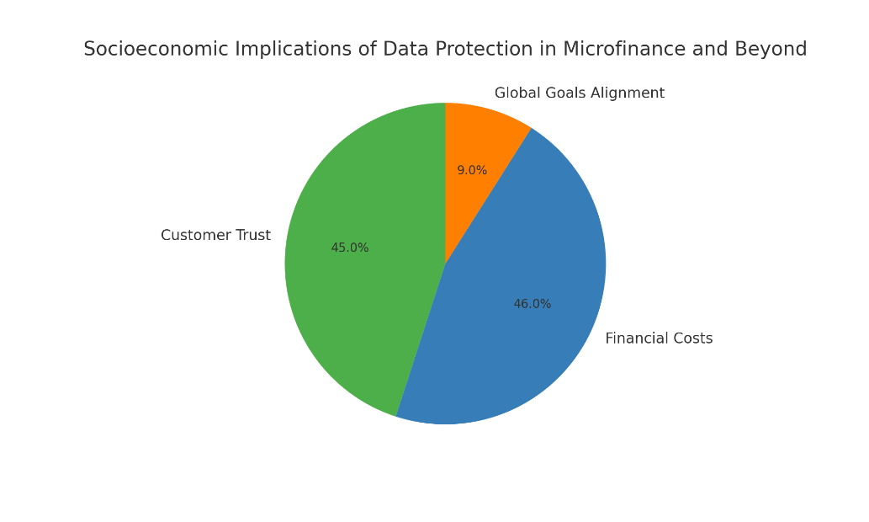
Figure 1 Socioeconomic implications of data protection in microfinance

1.6 Technological Infrastructure Challenges
Data breaches can really hurt microfinance institutions (MFIs), especially when you look at things from an economic viewpoint. The immediate costs, like those for investigating what went wrong, fixing the system, and paying lawyers, can add up quickly. But it’s the indirect costs that might hit them harder. When a breach happens, it can damage their reputation, cause clients to leave, and even make investors lose faith in them. Basically, one data breach can wipe out years of trust built with hard work and might even bring on penalties from regulators or lead to funding being pulled away.
Now, data protection is becoming a bigger deal when it comes to global development goals. The Sustainable Development Goals (SDGs) focus on things like strong industries, justice, and good partnerships, which all emphasize the need for solid infrastructure and trustworthy institutions. Keeping data safe plays, a crucial role in achieving these goals since it promotes responsible growth and compliance within the financial sector. But for MFIs in places like Cameroon to really protect their data, they need a strong tech setup, and unfortunately, many of them face tough challenges in this area that make it hard to keep sensitive information safe.
One big issue is internet connectivity. Lots of rural areas, where many MFIs operate, struggle with slow or unreliable internet. This can make it tough to do things in real-time, access services stored in the cloud, or even keep secure connections. When the internet is shaky, it can also slow down important updates and repairs, leaving these institutions open to common cyber risks.
Another challenge is the power supply. Frequent power cuts can really disrupt things, damage equipment and cause important data to be lost or systems to crash. Without a steady flow of electricity, MFIs can’t keep their servers running smoothly or ensure they have backup systems ready to go. Many must rely on expensive generators or battery backups, which not only costs a lot but isn’t great for the environment either.
Then there are hardware and software issues. A lot of MFIs are still using old computers that lack the speed and storage needed to run current security programs. On top of that, they might be using free or pirated software that doesn’t get updates or support, making them even more vulnerable to hacks.
Finally, there’s a big gap when it comes to skilled IT professionals. Many MFIs can't afford to hire full-time cybersecurity experts, so regular IT staff often end up trying to manage complex security setups. This can lead to mistakes and makes them more vulnerable to threats from within. Without the right training or access to the latest security tools, it’s hard for these institutions to effectively spot, react to, or stop data breaches from happening.
Putting all these issues together creates a risky environment for MFIs. Even if they have some good policies for data protection, those might not hold up in places where basic tech needs aren’t met. Fixing these gaps isn’t just about pouring money into physical infrastructure; it’s also about working together with government agencies, telecom companies, and international partners to create a secure digital environment that supports microfinance operations throughout Cameroon.

1.7 Problem Statement
Microfinance institutions face significant challenges in ensuring customer privacy and data protection amidst rising cyber threats, data breaches, and privacy infringements. These institutions handle sensitive personal data, making compliance with privacy regulations and investment in robust data security measures essential for maintaining customer trust and mitigating risks.

1.7.1 Emerging Threat Landscape
The rapid shift in the cybersecurity threat landscape is rapidly expanding, with significant new threats making their way to financial institutions including Microfinance Institutions (MFIs).
With the exponential growth of these digital infrastructures, so come the mechanisms and means used by cybercriminals. Cyber, of course -- threats like phishing, malware and basic brute-force surveys littered the early days of cybersecurity.
But today, these threats are more advanced in nature and multi-layer instead of a linear attack that leverage systemic failures within an ecosystem of the financial domain.
Ransomware as a service (RaaS), Advanced Persistent Threats (APT) and supply chain attacks as well as social engineering are now the norm in finance. Ransomware groups that had been picky and opportunistic have shifted to targeted campaigns toward specific institutions using machine-based reconnaissance, for example Zero-Day exploits. These novel actors are using AI and ML to craft better attacks that are stealthier, automating intrusions and evasion of detection mechanisms.
These emergent vulnerabilities are highly relevant in the context of developing economies where MFIs are especially at risk. It’s typically old hardware from limited budgets, software that is not well patched, underfunded security. Moreover, MFIs are heavily reliant on third-party vendors for digital services, and this often introduces new vectors (weakly secured APIs or network sharing with clients) that can be exploited.
These easy targets are often seen by threat actors in these environments. Because their leverage seldomly covered security weaknesses such as weak password policies, non-existent employee soft skills, and poorly prepared incident response plans. Additionally, geopolitical turmoil and local instability such along with lax regulatory oversight create a fertile ground for cybercrime.
Using pirated software, not much encryption and no multi-factor authentication (MFA) basically amplify the risks.
One of the most mentioned threats is the security lagging behind in matching up to the threat evolution. Threats develop fast sometimes on a weekly basis, or, with some social engineering vectors even faster but security updates at MFIs are being developed due to procurement procedures, funds are scarce or technical skills shortage. Passive monitoring and non-participation defines cumulating to a delay from which any institution is never entirely safe.
Not to forget, without the cyber threat intelligence capabilities or real time threat feeds MFIs are unable to predict and counter novel attack vectors.
Combatting this void will not only require technical fix, complemented by strategic planning and partnerships with cyber security organizations but also government support in building resilient infrastructure and threat response capabilities that are context adaptive.

1.7.2 Regulatory Compliance Burden
With increasing importance being placed on data protection, the regulatory environment for it also expands. MFIs are required to follow more and more data privacy and cybersecurity regulations that the frontend expects. It builds on national laws like Cameroon's Law No. 2010/012 on Cybersecurity and Cybercrime, regional intergovernmental guidelines and standards from donors.
Customer information regulations are necessary, but it is a heavy burden for MFIs in most developing countries to comply.
First and foremost, among the challenges facing MFIs is a difficulty interpreting convoluted legal provisions.
The regulations are either so wide or technical that MFIs typically have no legal or compliance expertise. As the result potential misinterpretation, partial compliance or non-compliance altogether due to vagueness. For example, basic requirements on data retention time frames, consent templates and cross border data transfer might not be comprehended so well or actual implemented.
The major problem is Compliance (and the cost of compliance) Playing to play, compliance requires a legal consultancy, staff training in data protection software as well as IT infrastructure that complies to high safety standards and regular audits.
Many of these costs are unaffordable for the thin-margin small MFIs. They do not have dedicated compliance departments they have to raid core operations to satisfy legal obligations of an equivalent size. The result of which helps us to restrict the better ability that they have in delivering affordable services to their clients.
Compliance frameworks are rarely context specific to developing countries as well. They might be banking on levels of technological sophistication or institutional strengthening that does not exist among MFIs in Cameroon. That means, compliant becomes operated for MFIs as necessities are replenished by regulatory aspect. Without clear guidance and support from regulators, the problem is made worse as institutions are left to figure out compliance by themselves.
The regulatory constraints incur this compliance vs Operational efficiency tug of war. On the one hand, non-compliance with the laws can lead to legal sanctions, reputational peril or loss of donor money etc. Conversely compliance processes that are too heavy handed can inhibit innovation, inhibit service delivery and increase client costs. MFIs, in short, therefore have to tread a fine line of abiding compliance while simultaneously delivering on their mission of financial inclusion.
For that regulatory bodies need to take a cue from risk-based and proportionate compliance approach and give some level of flexibility to smaller institutions. Incentivizing, as well as technical assistance; training can have a huge impact of relieving pressure off MFIs so that they can comply with regulations and deliver quality services while being financially sustainable.

1.8 Objectives
General Objective:
To examine and improve customer privacy and data protection mechanisms within microfinance institutions by analyzing existing policies and operational challenges, and by designing and implementing an integrated Secure Customer Data Management System.
Specific Objectives:
- To explore the fundamental principles of customer privacy and data protection relevant to microfinance institutions.
- To analyze the current data protection policies, technological controls, and compliance status of CCC Plc.
- To identify operational, infrastructural, and regulatory risks and challenges impacting effective data protection at CCC Plc.
- To assess the effectiveness of the implemented system and policies in mitigating cybersecurity threats and enhancing customer data privacy.
- To provide actionable recommendations for organizational reforms, staff training, and regulatory engagement to strengthen data protection practices in MFIs.

1.9 Research Question
Primary Research Question:
How can CCC Plc improve its data protection strategies to enhance customer privacy?

Secondary Research Questions:
- How effective are these measures in preventing unauthorized access and data breaches?
- What challenges do CCC Plc face in complying with data privacy regulations?
- What data protection measures are currently implemented at CCC Plc to safeguard customer information?

1.10 Scope and Limitations
This study examines CCC Plc's data privacy and protection policies, paying special emphasis to the ways in which client data is gathered, saved, handled, and safeguarded. The study looks at CCC Plc's internal procedures, technology security measures, and regulatory compliance. It may not, however, accurately represent the microfinance industry because it is restricted to the examination of CCC Plc's internal procedures.
The availability of CCC Plc's internal documents and data security regulations also places restrictions on the investigation. Although pertinent, external cyberthreats and third-party data handling are not the focus of this study.

1.11 Significance of the Study

1.11.1 Implications for Regulatory Development
This research has meaningful policy-relevant findings that may inform the creation of more effective and context-specific data protection regulations for microfinance institutions (MFIs) in Cameroon as well as similar environments. One thing that stands out is the requirement that regulatory frameworks adapted to the operational constraints of low and micro-finance institutions. Too often do we have overly prescriptive, commercial-bank-like regulations that make MFIs regulatory bodies before they are social enterprises.
We therefore recommend a hybrid regulatory framework that combines prescriptive components with principles; The first provides enforceable and clear standards (e.g., regarding encryption requirements or data breach disclosure by law) while the latter focuses on desired results rather than methodology.
For example, regulations can require that Institutions guarantee data confidentiality and integrity by means of suitable tools (defined by size and capacity) rather than prescribing any specific technical tool.
Regulators also have resources at their disposal and MFIs are already constrained. This entails process simplification for compliance, shared resources (i.e. shared CISOs/Legal counsel) and simplified policy-writing in plain English. There can be additional support for innovation and a minimum level of data security courtesy of regulatory sandboxes, as well as tiered compliance models.
In the end, regulation should protect consumer rights as well as support the growth of MFIs in delivering digital financial services through their footprint in underbanked areas. But by marrying regulatory requirements with the best practices gleaned from institutions like CCC Plc and other leaders, policymakers will be able to draft legislation that is enforceable and enabling.

1.11.2 Contribution to Digital Financial Inclusion
The importance of effective data protection to foster digital finance inclusivity is enormous. Trust is an important driver for digital services among low-income and other vulnerable populations. For example, improved data protection frameworks to build trust in digital financial systems that indicate FO to the customer that their personal information is safe and financial data is handled in a confidential manner.
The customer adoption and its relationship with data protection are in a cycle. Faced with confidence must be custodian of financial services data to increase mobile banking utilization across digital wallets and internet lending platforms. And bad publicity of high-profile data breach or exposure, tends to cultivate an overall distrust and lack of engagement in further using DP tools. So, it is not only mandated from a technical perspective but foundational to the basis of user experience and service adoption as well.
Builds financial inclusion around greater transparency, accountability and reliability. The mechanism, for instance, that audit logging and access control mechanisms can engender a security culture in an ecosystem where data integrity is a higher order mission. They could assist in financial literacy as it would be made possible for customers to monitor their own digital footprints and know how data is used.
By laying the groundwork for secure operation, MFIs will be able to expand and provide new forms of services digital savings group, micro-insurance even credit scoring using unstructured data with more confidence that their data is private.
This has the effect of more than doubling user retention and further unlocking the market, for inclusive growth.

1.11.3 Knowledge Transfer Potential
The framework and learnings generated through this research at CCC Plc can be a template for other MFI s, both in Cameroon and in similar economic cases The range of challenges they face may vary from institution and contextual constraints—emerging levels of cybersecurity literacy, ambiguous regulation or infrastructure bottlenecks among them
One way to transfer the knowledge could be developing best practices and industry norm at a high level. They might include data classification guidelines, enforced minimal security settings templates, model privacy policies unaffiliated with the companies in question created frameworks around managing customer consents. This will make the sector scale down duplication of investment, drop compliance costs and raise overall baseline for security by standardizing these elements.
This research further helps develop capacity in cybersecurity from the local level. It mixes a knowledge that fills awareness and infrastructure need to decide targeted training plans, course builds, as well as education developments. Local universities, training institutes and industry associations can take the results to design educational content that trains professionals for real-life financial cybersecurity problems.
In addition, the study fosters between MFIs the spirit of exchanging learnings, combined funding and collective efforts for regulatory reforms. Peer-to-peer learning and community building that help the microfinance institutions in a network become more resilient has also added security, stronger inter-law enforcement cooperation between institutions.

1.11.4 Economic Benefits Over the Long Term
Data protection is an incredibly cost-effective long-term economic investment. Avoiding data breaches shrinks the direct costs to incident response, ramifications of a breach on the customer, the fines from all relevant authorities and compensation reimbursements. Then, critically it maintains the customer trust, which is one of the most precious assets for MFI too.
Having customers confident in their bank fosters longer relationships, they use more of the products & services offered and will even vouch for the bank. This ultimately drives more revenue, lower attrition and a steadier customer demographic. However, a data breach is the exact opposite and can easily cost you money: customer leaks, confiscation of all funding and sometimes the subsequent downfall of an entire institution.
Data protection re-re-ensures the securities of the entire economy. Amy, as MFIs are becoming increasingly digitized from end-to-end, they are connected more and more deeply with a national financial infrastructure. A security breach in one institution can be a systemic vulnerability especially if institutions are linked through common platforms or connected one way or another through payment systems. Therefore, data protection is of macroeconomic impact and increases the moderate wings of financial overall resilience.
Finally, data protection enables revenue growth for business with a focus on sustainability. MFIs can plan for their sustainability with security and privacy embedded into operations. Not only is this at the heart of what a customer wants, but it is also increasingly attractive to investors and development partners that emphasize Environmental, Social and Governance (ESG). Data protection: This turns out to be what sets competitive markets apart and contributes to broader economic objectives like competitiveness.

For many stakeholders, the research's conclusions are extremely important. The research contains suggestions for improving customer privacy as well as a thorough examination of CCC Plc's present data protection practices. This study provides a paradigm for enhancing data security in accordance with international best practices for the larger microfinance industry. The information offered may also help policymakers create strong regulatory frameworks that strike a balance between data privacy issues and financial inclusion.
In the end, this study emphasizes how crucial it is to protect private financial data in microfinance organizations, which helps to increase security and trust in online financial services.

1.12 Organization of the Study
This study is divided into 5 main chapters which are as follows:
Chapter 1: Introduction
By outlining the study's background, problem statement, research questions, aims, scope, constraints, and importance, this chapter offers a fundamental grasp of the research issue. With an emphasis on CCC Plc specifically, it presents the ideas of data protection and client privacy in the context of microfinance organizations. The chapter also emphasizes the difficulties MFIs encounter in protecting private client information in the face of rising digital transformation and regulatory demands.
Chapter 2: Literature review
The literature review explores current studies and theoretical models on information security, data privacy, and data protection in microfinance organizations. It investigates regional and international viewpoints on regulatory compliance, the function of digital financial technology, and data protection procedures. The chapter also discusses gaps in the literature on microfinance institutions in underdeveloped nations, especially Cameroon, and looks at best practices for protecting consumer information.
Chapter 3: Methodology
The research strategy, methods, and data collection strategies used in the study are described in this chapter. It explains the case study methodology, sample techniques, primary and secondary data sources, and data analysis tools. The chapter also covers data privacy practices during research, ethical issues, and the validity and dependability of findings.
Chapter 4: Data Analysis, Design, Implementation and Findings
The data analysis from CCC Plc is presented in Chapter 4. It comprises an analysis of the organization's present data security measures, weaknesses, and level of regulatory compliance. The results are examined considering the goals and study questions, emphasizing both the strengths and room for development in terms of protecting consumer privacy.
Chapter 5: Conclusions and Recommendations
The research's main conclusions are outlined in the last chapter, which also offers practical suggestions for improving data security and privacy in microfinance organizations. Additionally, it offers regulatory policy implications as well as doable actions that CCC Plc might take to improve its data security system. Unresolved issues found during the study are addressed by suggested future research directions.

Conclusion:
This chapter concludes by establishing the indispensable role of robust data protection practices in enabling MFIs to operate securely while fostering financial inclusion. It underscores the study’s purpose to analyze existing gaps and propose improved mechanisms, thereby setting a clear roadmap for subsequent chapters that will delve deeper into theoretical background, methodology, system design, analysis, and practical recommendations.

Chapter 2: Literature Review
This chapter reviews prior academic and industry literature relevant to microfinance, financial inclusion, and especially customer privacy and data protection. It examines theoretical frameworks explaining financial inclusion, the rapid digitalization of microfinance services, and the emergence of data privacy as an essential facet of digital financial services. The review extends to regulatory landscapes, cybersecurity threats, existing solutions, and identifies critical research gaps, particularly for MFIs in developing economies like Cameroon. This foundation is critical for situating the study’s contribution within the broader knowledge environment.

2.1 Microfinance and Financial Inclusion
Microfinance has emerged as a crucial tool in the fight against global poverty, providing access to financial services to individuals and communities traditionally excluded from the formal banking system (Zhang, 2017). By providing insurance products, savings accounts, and modest loans, microfinance institutions (MFIs) enable underserved groups, especially women and small business owners, to become more financially stable. But as the microfinance sector keeps growing, questions have been raised about how these institutions are protecting the data and privacy of their clients. Protecting customer data has become a critical issue that demands attention from both MFIs and regulatory agencies as financial services become more digitally integrated.

2.1.1 Theoretical Frameworks of Financial Inclusion
Principal Theoretical Models
With the roots in development economics and theories of relieving poverty, microfinance has been defined from its very foundation. The relationship between financial inclusion and economic empowerment has been explained by the conventional models like Financial Intermediation Theory, Credit Rationing Theory. These principles argue that the availability of credit allows investments in productive work, which subsequently raises income and reduces poverty.
The microfinance discourse has been shaped by the Capability Approach of Amartya Sen as well who described financial services as ‘freedom tools’ to enable people to undertake lives that they value. Focusing on this, Microfinance enables users not just to break out of poverty but also ratchet up their capabilities.
The Development of Financial Inclusion Theories
Initial Consideration of Credit Access leading to more everywhere models for financial inclusion. However, more contemporary frameworks now catch the importance of total bundles of a service savings/insurance/purposes system.
In the switch, it recognizes that there is a need for plural finance instruments to deal with risk, plan and nurture long term development.
Digital Financial Services
Digital financial services have reshaped the theory in a big way. Mobile banking and digital wallets are some of the new innovations that introduced changes to traditional models by lowering the cost of transactions, banking the un-banked. Theories stand not only with insights from network economics, but on platform delivery and data-driven finance behavior.

2.2 Digitalization in Microfinance:
The integration of digital technologies into microfinance institutions (MFIs) has transformed service delivery. Mobile banking, digital payment platforms, and AI-driven credit assessments have enabled MFIs to reach underserved populations, particularly in rural areas. These advancements facilitate scalable operations and tailored financial products, contributing to poverty alleviation and economic empowerment.(Mamadiyorov et al., 2023)
Data Security in the Digital World
Protecting client data is crucial as MFIs digital. Strong data protection procedures are required for the gathering and handling of financial and personal data in order to guard against illegal access and guarantee legal compliance. Data privacy is emphasized by frameworks such as the General Data Protection Regulation (GDPR), which requires user consent and transparency in data processing procedures.(n.d.)
Digital Risks in Microfinance
The digital transformation of microfinance introduces several risks:
- Cybersecurity Threats: Increased reliance on digital platforms exposes MFIs to cyberattacks, including data breaches and fraud.
- Operational Risks: Technical failures or system downtimes can disrupt services, affecting customer trust and financial stability.
- Regulatory Compliance: Navigating the complex landscape of data protection laws requires ongoing diligence to avoid legal repercussions.(Data Privacy and Protection | CGAP, n.d.)

2.3 Data Privacy and Protection
Concerns about data security and privacy have grown significantly in the financial industry, especially since the introduction of digital financial services. In addition to being required by law, protecting consumer data is also a business necessity that builds consumer loyalty and trust (Is Data Privacy Good for Business? 2018). Sensitive information like identity numbers, bank account information, and transaction histories are commonly included in client data in the context of microfinance. Unauthorized disclosure or improper handling of sensitive data may result in serious financial and reputational consequences.
The European Union's General Data Protection Regulation (GDPR), which went into force in 2018, established a standard for data protection around the world. It imposes strict guidelines for the gathering, use, and preservation of personal information, placing a strong emphasis on client consent, data minimization, and the right to be deleted. Following these rules is essential for MFIs to stay out of trouble with the law and keep the trust of their clients, especially those growing into digital services.

2.3.1 Theoretical Foundations of Data Privacy
Philosophical Perspectives
Privacy is just about the only human right we all agree on. Other philosophers like Alan Westin have contended that privacy is requisite for the self, the dignity and democratic check-in of individuals. This notion of control over your personal data is the foundation of trust and agency in the financial world
Utilitarian Vs Rights-Based Considerations
The utilitarian perspective in data protection aims at the improvement of total utility; this makes us give trade-off between privacy and service delivery efficiency versus quality. This means that rights-based approaches see individual privacy (despite the non-monetary economic implications) as sacrosanct. In other places the complexities of implementing privacy policies can make challenging trade-offs between security and service access so MFIs have up in arms.
Cultural Dimensions
Privacy is culturally invented. Individual Data ownership and the notion that their concept is different in societies who are collectivist from Western norms. MFIs need to take into consideration the role of cultural values on what customers want and regulators may accept.

2.3.2 Privacy by Design Principles
Foundational Principles
The seven principles are:(Cavoukian, n.d.)
- Proactive not Reactive; Preventative not Remedial
- Privacy as the Default Setting
- Privacy Embedded into Design
- Full Functionality — Positive-Sum, not Zero-Sum
- End-to-End Security
- Visibility and Transparency
- Respect for User Privacy(n.d.)
Application to Resource-constrained Settings
Realistically, full deployment of privacy by design in low-resource contexts can be hard to achieve fully. Core principal prioritization (e.g. default privacy and visibility) has large upsides backed by minimal costs.(Danezis et al., 2015)
Case Studies
Estonia: Estonia's e-governance system exemplifies PbD by allowing citizens to monitor who accesses their data, promoting transparency and trust.(What Is Privacy by Design?, n.d.)
India (Aadhaar): India's Aadhaar system introduced features like Virtual ID and tokenization to enhance privacy. However, challenges remain in ensuring comprehensive privacy protections.(n.d.)

2.3.3. Economic Models of Privacy
The Importance of Individual Information
Data is frequently referred to be the "new oil," and organizations use personal data for marketing, credit scoring, and service creation. However, customers hardly ever recognize the value of their data or receive payment for its use.
Benefit-Cost Models
Research indicates that even little expenditures in data governance, permission management, and encryption greatly lower the likelihood of losses from breaches. It's critical for MFIs to balance privacy investments with possible breach cost reductions.
Two Economic Views
Data is a strategic asset from an institutional standpoint. Customers may experience financial loss, identity theft, or exclusion from future services because of data loss. It is important to balance these viewpoints.

2.3.4. Psychological Aspects of Privacy
1. Psychology of Customers
Customers continue to give data freely despite surveys frequently reveal serious privacy concerns, a contradiction known as the privacy paradox.
2. The Paradox of Privacy
According to behavioral economics, consumers, particularly in digital banking, sacrifice privacy for convenience. This disparity can be closed with the use of user-friendly consent procedures and awareness efforts.
3. Mechanisms of Trust
Trust is increased by transparency, reputation, and obvious security measures. MFIs can boost data sharing willingness by using human-centered design, clear policies, and branding.

2.3.5 Data Minimization and Purpose Limitation
1. Best Practices
Clear retention terms, timely deletion of unnecessary data, and only gathering relevant data are examples of best practices.
2. Protection vs. Utility
Institutions sometimes struggle to balance their responsibility to protect privacy with their demand for extensive data sets. This conflict can be lessened by designing systems with modular permissions and anonymized data processing.
3. Useful Methods
MFIs can adopt minimization without complex infrastructure by using straightforward methods like automated deletion protocols, data inventory checks, and consent checklists.

2.4 Regulatory Landscape

2.4.1 Issues related to customer privacy and data protection.
Income levels, spending habits, credit histories, and loan repayment records are just a few of the sensitive financial and personal data that MFIs frequently gather and handle from their clients. Monitoring institutional performance, customizing financial products, and assessing creditworthiness all depend on this data. However, a lot of MFIs have a limited technology infrastructure, which leaves them especially susceptible to unauthorized access, cyberattacks, and data breaches. Inadequate cybersecurity safeguards raise the possibility of identity theft, financial fraud, and misuse of customer information.
Previous studies have highlighted the importance of robust data protection policies and practices within microfinance institutions. (Koveos & Randhawa, 2004) noted that the assessment of MFI performance must consider not only their economic efficiency but also their social impact, which includes the ethical treatment of clients and the safeguarding of their personal information. (Kayembe et al., 2021) emphasized that the sustainability of MFIs is closely tied to their ability to maintain the trust of their clients, which is directly linked to their data protection measures(Koveos & Randhawa, 2004).
For microfinance organizations, figuring out how long to keep customer data is a complex problem. Long-term retention periods pose privacy concerns, even if they are required for maintaining historical records and evaluating credit risk. Microfinance organizations must set up transparent and unambiguous policies for the storage and disposal of data. The goal of data retention, legal obligations, and the necessity to safeguard client privacy should all be considered in these rules. Adopting appropriate data preservation procedures protects customer confidentiality and confidence while guaranteeing adherence to pertinent laws.(n.d.)
Many microfinance institutions face financial and technological constraints, making it difficult to implement industry’s best practices for data protection. Some MFIs lack the skills and funding to deploy strong encryption techniques, secure data storage systems, and cybersecurity training for their workers. Furthermore, due to the informal character of microfinance in some locations, many transactions are handled on paper or unprotected digital platforms, raising the risk of data breaches. Addressing these issues requires a combination of institutional commitment, regulatory monitoring, and technical innovation.

2.4.2 Issues related to regulation.
The regulatory environment plays a significant role in shaping the data protection practices of MFIs. Governments and financial regulatory bodies establish policies that dictate how customer data should be collected, stored, and shared. However, in many developing countries where microfinance is most prevalent, regulatory frameworks for data protection remain weak or inconsistently enforced(n.d.). The absence of clear legal guidelines on data privacy can lead to lapses in security, making clients more vulnerable to financial exploitation.
Several studies have explored the impact of regulatory frameworks on MFI data protection practices. Some argue that stricter regulations can enhance client confidence in microfinance services, thereby increasing participation rates and financial inclusion. Others caution that overly rigid data protection laws could place an additional burden on MFIs, especially smaller institutions with limited resources. Striking a balance between protecting customer data and ensuring the operational efficiency of microfinance institutions is crucial for the industry's long-term growth.
Financial technology (fintech) firms and international organizations have stepped in to help MFIs bolster their data security protocols in recent years. Blockchain-based lending platforms and mobile banking are two examples of digital financial services that present new chances for safe transactions. To guarantee that consumer data is protected, these technologies must be adopted with sufficient training, awareness-raising initiatives, and governmental backing.
The rapid rise of the microfinance industry has provided financial opportunity to underprivileged areas, but it has also created new vulnerabilities in terms of data privacy and security. Ensuring the ethical and secure handling of consumer data is crucial to sustaining trust in the industry. While some MFIs have taken proactive initiatives to improve data security measures, many continue to confront issues because of insufficient resources and inadequate regulatory monitoring. Strengthening data protection frameworks, boosting technological improvements, and encouraging collaboration among MFIs, regulators, and technology providers can all assist to overcome these concerns. Future studies should look into novel solutions that balance financial inclusion with strong data security in the microfinance sector.

2.4.3 Comparative Analysis
1. African Frameworks, CCPA, and GDPR
While the CCPA promotes transparency and opt-out rights, GDPR places more emphasis on rights (such as the right to deletion and data transfer). African frameworks, such as Kenya's DPA or Nigeria's NDPR, frequently combine the two, but they struggle with resources and enforcement.
2. Advantages and Disadvantages
The CCPA is easier to understand but has a more limited scope than GDPR, which is both extensive and complex. African laws require further localization and clarification.
3. Difficulties with Harmonization
Harmonization is made more difficult by cross-border financial services. Solutions could be provided by standardized regulatory templates and regional data protection authorities.
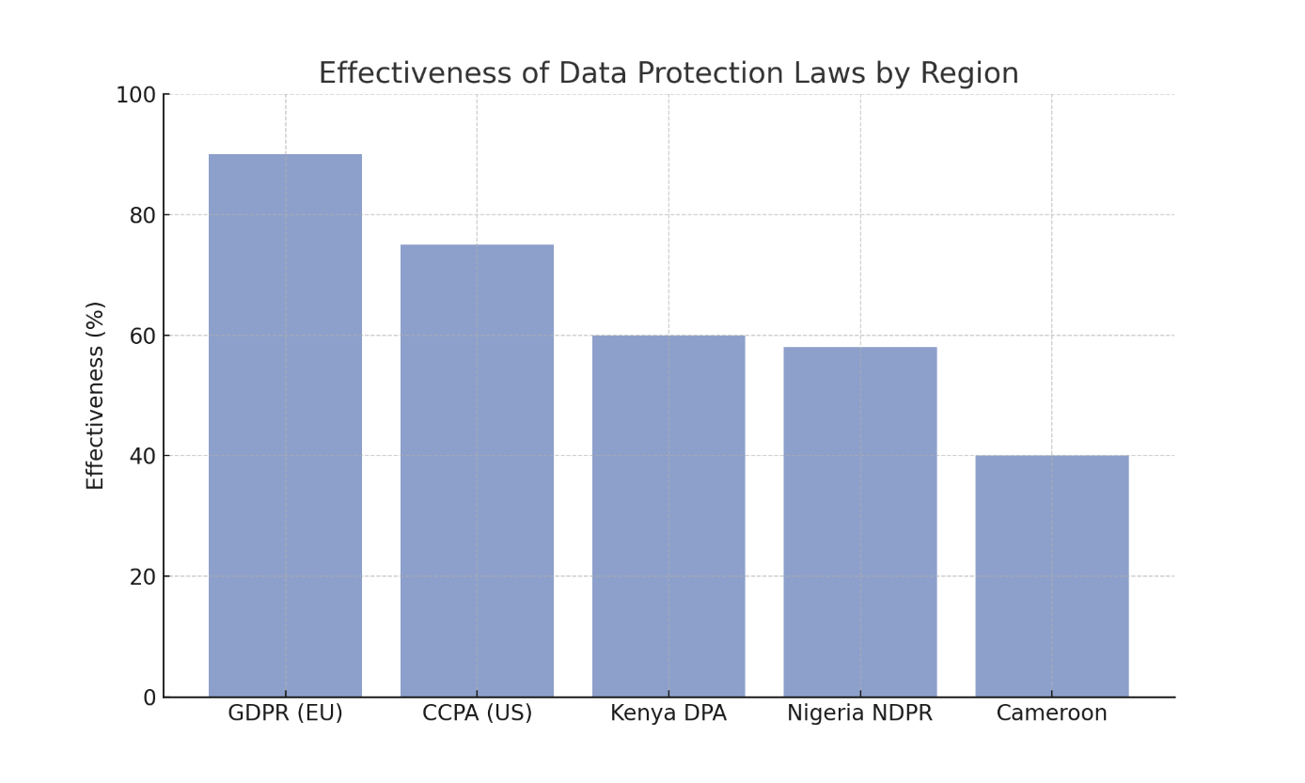
Figure 2 Effectiveness of Data Protection Laws by Region

2.4.4 Evolution of Financial Regulations
1. Development
Regulations have evolved from bank secrecy laws to multi-faceted privacy regimes encompassing digital wallets, mobile credit, and cryptocurrency.
2. Adapting to Digitalization
Supervisory bodies now require data breach reporting, digital KYC protocols, and cybersecurity frameworks.
3. Cybersecurity Integration
Institutions are increasingly mandated to conduct risk assessments, designate data protection officers, and follow ISO 27001-like standards.

2.4.5 Self-Regulation and Standards
1. Industry Associations
Entities like the Smart Campaign and GSMA promote self-regulatory guidelines, including client data principles for financial services.
2. Effectiveness
Self-regulation often works where regulatory capacity is low but lacks legal enforceability. Hybrid models can bridge the gap.
3. Certification
Certifications (e.g., ISO/IEC 27001) signal security readiness and improve market reputation. However, cost barriers persist for MFIs.

2.5 Common Cybersecurity Threats Facing MFIs
Human-related vulnerabilities are the main cause of the growing cyber threat vulnerability of microfinance institutions (MFIs). Because workers are frequently the weakest link in security measures, these vulnerabilities make MFIs great targets for fraudsters. Social engineering attacks, including spear-phishing and phishing, are a significant problem since they exploit employees' lack of cybersecurity expertise. Employees could unintentionally divulge private information, click on dangerous links, or install dangerous software, putting the organization at serious risk.
Given that MFIs manage large volumes of sensitive financial and client information, a successful phishing attack can have severe consequences, such as data breaches, financial losses, or unauthorized access to customer accounts. The problem is worsened by the heavy reliance on digital transactions, where cybercriminals can easily impersonate legitimate entities to deceive employees into granting access.(Waweru et al., 2024)
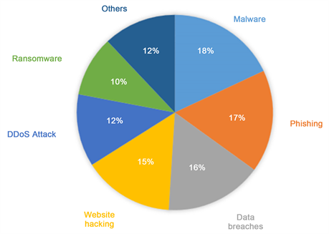
Figure 3 Common Cybersecurity Threats Faced by MFIs
Some of the most common cybersecurity threats facing MFIs include:
- Phishing Attacks
One of the most common types of cyberthreats directed at financial institutions is still phishing. Cybercriminals frequently deceive staff members or clients into divulging private information, including login passwords or financial information, by sending them phony emails or messages that look authentic. MFIs are especially susceptible to these kinds of assaults since they do not have advanced email screening systems.
- Malware and Ransomware
Digital banking platforms are seriously threatened by malware, especially ransomware. While malware can steal private data, interfere with business processes, or grant unwanted access to financial records, ransomware assaults encrypt organizational data and demand money to unlock it. Recovering from such assaults can be extremely costly for MFIs with small IT budgets.
- Data Breaches
Unauthorized access to and retrieval of private client data is known as a data breach. Social engineering, hacking, or flaws in digital systems can all cause this. Financial loss, harm to one's reputation, and noncompliance with data protection laws are all outcomes of data breaches.
- Insider Threats
When current or former employees abuse their access to data systems for nefarious or personal purposes, insider dangers arise. Compared to larger financial institutions, MFIs may have less strict access control measures, which increases this risk.
- Distributed Denial of Service (DDoS) Attacks
DDoS assaults flood a server or network with traffic, making it unavailable to authorized users. This can interfere with important financial transactions, damage client confidence, and cause MFIs to stop operations for a long time.
- Third-Party Vulnerabilities
MFIs often rely on third-party service providers for IT solutions and digital banking platforms. These partnerships, while cost-effective, introduce security risks if the third party lacks robust cybersecurity measures. A breach within a service provider’s infrastructure could compromise the MFI’s sensitive data.

2.6 Existing Data Protection Solutions
To combat the growing threats of cyber-attacks, MFIs have adopted various data protection solutions designed to safeguard customer information and maintain the integrity of financial services. Some of the key solutions include:
1. Data Encryption
Data encryption transforms readable information into a coded format that can only be deciphered with a specific decryption key. This ensures that even if data is intercepted, it remains unintelligible to unauthorized users. MFIs are increasingly using encryption protocols for both data at rest and data in transit.
2. Multi-Factor Authentication (MFA)
MFA adds an additional layer of security by requiring users to provide two or more verification factors before accessing sensitive information. For MFIs, this significantly reduces the risk of unauthorized access to digital banking platforms and client information.
3. Secure Access Controls
Access control mechanisms help restrict data access based on user roles and responsibilities. By limiting access to critical systems, MFIs can minimize the risk of data breaches stemming from insider threats or unauthorized personnel.
4. Regular Security Audits
Frequent security audits allow MFIs to identify vulnerabilities within their IT infrastructure and address them proactively. Audits help ensure compliance with regulatory standards and enhance overall cybersecurity resilience.
5. Employee Training and Awareness
A significant number of cyber incidents are triggered by human error. Regular training on cybersecurity best practices helps MFI employees recognize phishing attempts, avoid malware infections, and follow proper data handling procedures.
6. Cloud-Based Security Solutions
Cloud service providers often offer robust security measures such as encryption, automated backups, and real-time threat monitoring. For MFIs, adopting cloud-based solutions can enhance data protection while reducing on-premises security burdens.
7. Compliance with Data Protection Regulations
Adherence to data protection regulations such as GDPR, CCPA, and local cybersecurity laws help MFIs establish structured protocols for handling sensitive information. Compliance not only protects client data but also mitigates the risk of legal penalties.

2.7 Research Gap Identification
While there is widespread use of digital financial system, a lot of debates around customer privacy and data security of Microfinance Institutions (MFIs) continue to persist in developing economies such as Cameroon. Big banks have implemented robust data security systems to safeguard sensitive information, but we see MFIs struggling to implement similar measures for a variety of reasons including resource constraints, infrastructure challenges and weak regulatory enforcement. However, the literature primarily covers security of data in conventional banking sectors and with very little academic attention paid to how MFIs, in particularly in financially immature markets, handle privacy of addressing customer data in an era of rampant cyber insecurities.
Current research focus on the general features related to financial inclusion, cyber security threats, and regulation compliance. Yet there is a significant knowledge gap regarding particular challenges MFIs face in having effective data privacy. Additionally, the incorporation of digital technologies like online transactions and mobile banking has increased MFIs' data exposure, calling for more robust privacy standards that have not yet been thoroughly examined in the literature.
Law No. 2010/012 on Cybersecurity and Cybercrime serves as the framework for data protection regulations in Cameroon. Although the legal underpinnings for data protection are established by this law, its actual implementation in MFIs is still restricted. How these organizations manage legal compliance while striking a balance between operational effectiveness and customer data protection is not adequately covered in the literature currently in publication. Additionally, there aren't many case studies that particularly address how MFIs in Cameroon, like CCC Plc, apply data privacy policies in the face of technological and infrastructure obstacles.
Assessing consumer knowledge of data privacy in MFIs is another crucial study gap. MFIs usually lack organized programs to educate consumers about their data rights and privacy issues, but larger financial institutions frequently participate in customer education activities. Clients may unintentionally expose their information to risks during digital transactions due to this ignorance, which might worsen vulnerabilities.
Furthermore, as third-party providers use APIs to obtain sensitive financial data, the emergence of "open banking" efforts creates new vulnerabilities. While research has looked at how open banking has affected conventional banks, less attention has been paid to how this digital transformation impacts MFIs in emerging nations. In the context of microfinance, the ramifications for client trust, data privacy, and regulatory alignment are yet mostly unexplored.
By providing a thorough examination of CCC Plc's client privacy and data security policies, this study seeks to close these gaps and shed light on the possibilities and difficulties faced by MFIs in Cameroon. By identifying weaknesses in data protection procedures, evaluating regulatory compliance, and suggesting tactical solutions to improve data security in the microfinance industry, the study aims to add to the body of knowledge already in existence.

Conclusion:
The literature review reveals significant challenges faced by MFIs regarding data privacy stemming from limited resources, evolving cybersecurity threats, and regulatory complexities. It highlights inadequacies in existing research focused primarily on traditional banking sectors with insufficient attention to MFIs’ unique vulnerabilities. Consequently, this chapter validates the study’s necessity, highlighting areas where empirical investigation and practical system design can advance understanding and improve data protection in microfinance institutions.

Chapter 3: Methodology
In this chapter, the research design, methods, and analytical approaches adopted for this case study on CCC Plc are articulated. The mixed-methods approach combining qualitative interviews and quantitative surveys is justified to comprehensively assess organizational data protection practices. It explains case selection rationale, sampling strategies, data collection techniques, ethical considerations, and analysis methods, ensuring rigor and reliability. The methodology underpins how the study will empirically investigate data privacy challenges and technological capabilities within the MFI.

3.1 Research Design
The study uses a case study methodology and focuses on CCC Plc, a Cameroonian microfinance organization. Because it enables a thorough examination of intricate problems pertaining to data privacy and protection in a practical setting, a case study technique is appropriate for this research. A thorough grasp of the procedures, difficulties, and best practices used by CCC Plc to protect consumer data is made easier by this design. In order to enhance the analysis, the study also uses a mixed-methods approach, integrating both qualitative and quantitative data. Staff interviews are used to gather qualitative data, and structured surveys are used to gather quantitative data. This combo offers an impartial viewpoint on the institution's data protection procedures and staff knowledge.
For this study, the mixed-methods technique works especially well because it makes use of both qualitative and quantitative research's advantages. Deep insight into the experiences, difficulties, and opinions of CCC Plc's employees about data protection are offered by the qualitative component. A comprehensive grasp of the institution's present privacy and security situation is made possible by the quantitative data, which provides quantifiable indicators of staff awareness, system vulnerabilities, and data protection procedures.

3.2 Case Study Selection
CCC Plc was specifically chosen as the research's case study because of its significant contribution to Cameroon's microfinance industry and dedication to digital financial services. CCC Plc is a representative model for researching data privacy and protection issues because it is one of the top microfinance organizations in the area and manages large amounts of client data. Additionally, using digital banking services exposes it to more cyberthreats, which offers a useful framework for analyzing data security protocols.
Furthermore, CCC Plc's activities are firmly rooted in marginalized areas where financial inclusion is essential. It is a good model for assessing how digitization affects consumer privacy and data security because of its dedication to digital transformation. The choice of CCC Plc also makes it possible to investigate the application of legal frameworks such Law No. 2010/012 on Cybercrime and Cybersecurity in Cameroon's microfinance operations.

3.3 Data Collection Methods
Staff members of CCC Plc were the target of questionnaires and interviews used to gather data for this study. The study, which was organized around a thorough questionnaire, collected quantifiable data about employee problems, security procedures, management of customer information, and data privacy awareness. Among the questionnaire's important components were:
- General Information: Capturing demographic and professional details of respondents.
- Knowledge and Awareness: Assessing familiarity with data protection policies and regulatory compliance.
- Data Handling and Security: Understanding measures for secure data storage and authorized access.
- Customer Data Sharing and Consent: Exploring practices for obtaining consent and sharing customer information with third parties.
- Challenges and Recommendations: Identifying obstacles to data protection and potential improvements.

3.4. Sample and Sampling Techniques
Purposive sampling was used in the study to choose individuals who work directly with CCC Plc's data management and information security. To ensure a varied representation of viewpoints, the sample comprised staff members from several departments, such as IT, Customer Service, and Compliance. Ten in-depth interviews were conducted in addition to the 50 survey results that were gathered. It was determined that this sample size would adequately capture the quantitative and qualitative aspects of the institution's data protection procedures.
Because it allows targeted data collecting from people with specialized knowledge or experience in data privacy and protection, the purposive sampling method was selected. This strategy made sure that the information gathered was pertinent and in line with the goals of the study.

3.5. Processes, Methods, Techniques, and Tools
The development of the Secure Customer Data Management System is guided by structured processes, methods, techniques, and tools:
- Processes:
  - System Development Lifecycle (SDLC): This includes phases such as Planning, Analysis, Design, Implementation, and Maintenance, structured to deliver a secure and efficient data management system.
- Methods and Techniques:
  - Unified Modeling Language (UML): Used for system design, including use case diagrams, class diagrams, and sequence diagrams, to visualize system architecture.
  - Prototyping: The system interfaces were prototyped using React (tsx files), allowing iterative feedback and adjustments.
  - Agile Development: The project followed an agile methodology to allow incremental development, frequent testing, and quick adjustments based on stakeholder feedback.
  - Structured Analysis and Design Technique (SADT): Employed to model processes and data flows, ensuring clear definitions of system interactions.
- Tools:
  - Development Tools: Nextjs for frontend development, MySQL for database management with AES encryption for data security.
  - Database Management: MySQL with AES encryption for secure data storage.
  - Security Tools: Audit logging to track data access, access control mechanisms to restrict unauthorized users, and encryption protocols.
  - Privacy Management Tools: A privacy rights portal allowing customers to request data deletion or correction.

3.6. Data Analysis Techniques
There were two phases to the data analysis process:
Quantitative Data Analysis: To find patterns in staff members' awareness, security procedures, and compliance levels, survey data was examined using descriptive statistics. Responses from different departments and experience levels were compared using frequency distributions and cross-tabulations.
Qualitative Data Analysis: Thematic analysis was used to look at interview transcripts, concentrating on recurrent topics such data protection issues, awareness gaps, and suggestions for enhancement. To uncover trends and derive insights that support the quantitative results, coding techniques were used.

3.7. Case Study: Data Management Practices at CCC Plc

3.7.1 Overview of CCC Plc
Established in November 1998, CCC Plc is a globally diversified company headquartered in Douala Cameroon. Initially founded as a co-operative society, the organization transitioned into a public limited company, evolving into a key player in the financial services sector. Today, CCC Plc operates through a network of approximately 20 branches, strategically located in both urban centers and rural communities. This extensive reach underscores its commitment to fostering financial inclusion and socioeconomic development across Cameroon.
CCC Plc has a customer base of over 115000 composed of current and savings accounts. In addition, they handle salary transfers for both public service (civil servants) and private sector workers.
CCC Plc’s Vision
To be the leading financial institution within the sub region.
CCC Plc’s Mission
To provide quality services for customer satisfaction.
Through an effective and proactive management system, CCC Plc, which is based on transparency and trust, places a high priority on customer proximity and satisfaction. These values have not only fueled its operational excellence but also cemented its standing as a reliable leader in the field.
CCC Plc’s Core Values
  - Rapid quality services
  - Customer care
  - Flexibility and innovation
  - Discretion and confidentiality
  - Team spirit
  - Respect for laws and regulations

3.7.2 Data Collection and Storage
Type of data collected by CCC Plc
To evaluate creditworthiness, control risk, and customize services, CCC Plc gathers a variety of consumer data. This comprises transaction history, financial information, behavioral insights, and basic demographic data. Additionally, they gather data on customer interactions, loan applications, and repayment histories.
- Basic Customer Data: Name, address, age, gender, occupation, and income are examples of demographic data.
Contact Details: Email addresses and phone numbers are gathered for correspondence.
Identification: This could include different types of identification or national identification numbers.
- Financial Information:
Earnings and Outlays: MFIs evaluate borrowers' ability to pay back loans.
Asset Information: Creditworthiness may be determined using information on assets, such as real estate or land.
Credit History: When determining creditworthiness, repayment history with other institutions is considered.
Loan Application Information: Specifics of loan applications, such as loan amount, purpose, and payback plan.
- Transactional Information:
Loan Repayment Records: Documentation of loan payments, including dates and amounts.
Savings Transactions: Details regarding withdrawals and deposits.

3.8. Ethical Considerations
Strict ethical procedures were followed in this study to protect participants' privacy and confidentiality. Prior to their involvement in the survey and interviews, all respondents gave their informed consent. No personal identifiers were gathered, and respondents were guaranteed the anonymity of their answers. Only authorized research staff had access to the safely kept data that was gathered during the study. The study was also carried out in accordance with Law No. 2010/012 of December 21, 2010, on Cybercrime and Cybersecurity, guaranteeing adherence to national data protection laws.
Along with ethical precautions, the combination of qualitative and quantitative data gathering techniques guarantees the validity and dependability of results while upholding participant privacy and institutional confidentiality.
Conclusion:
The methodology chapter concludes that the chosen research design, integrating both qualitative and quantitative data, effectively captures the multifaceted realities of data privacy practices at CCC Plc. It provides a robust foundation for the detailed analysis presented in subsequent chapters, ensuring that insights and recommendations emerge from sound empirical evidence and ethical research standards.

Chapter 4: Analysis, Design, Implementation, and Findings
This chapter presents a comprehensive analysis of CCC Plc’s current data privacy and protection practices, supported by technical system design and implementation details of an integrated Secure Customer Data Management System. It describes system requirements, architectural design, security protocols (e.g., AES-256 encryption, role-based access control, audit logging), and user interface features such as the privacy management portal. By pairing empirical findings with technical solutions, it addresses operational challenges and regulatory compliance gaps within the MFI.

4.1 System Requirements
To ensure the secure and efficient management of sensitive customer and transactional data, microfinance institutions (MFIs) require a robust technological infrastructure. The system must integrate dependable hardware, up-to-date software, and comprehensive security measures to support digital financial services in often resource-constrained environments. Below is a breakdown of the essential system requirements.
Hardware Requirements
A stable IT infrastructure starts with modern hardware capable of handling data-intensive financial operations. These requirements ensure MFIs can maintain uptime, process transactions securely, and interact reliably with cloud-based platforms:
- Server: Minimum of 4 CPU cores and 8GB RAM
- Storage: At least 100GB SSD for application and database
- Network: Reliable internet connection with a minimum 10Mbps bandwidth

Software Requirements
A solid software stack enables MFIs to build scalable, secure, and feature-rich applications. Updated systems also help maintain compatibility with evolving technology standards and regulatory requirements:
- Operating System: Linux (Ubuntu 22.04 LTS) or Windows 11
- Web Server: Node.js 18.x or higher
- Database: MySQL 8.0 or above
- Framework: Next.js 14.x or later
- Runtime Environment: Node.js 18.x or higher

Security Requirements
Given the sensitive nature of financial data, security is paramount. MFIs must implement strong encryption, rigorous access controls, and audit mechanisms to protect client information and adhere to regulatory standards:
- Encryption: AES-256 encryption for storing and transmitting sensitive data
- Authentication: Support for multi-factor authentication (MFA)
- Authorization: Role-based access control (RBAC) to limit user permissions
- Audit: Detailed and tamper-proof audit logging
- Compliance: Adherence to GDPR, CCPA, and applicable financial regulations
- Data Protection: Enforcement of data minimization and privacy-by-design principles

Functional Requirements
Functionality must align with both operational needs and regulatory expectations. The system should empower MFIs to manage customer data securely, train staff, enforce access policies, and uphold customer privacy rights:
- User Authentication & Authorization
- Customer Data Management
- Privacy Rights Management Tools
- Staff Training Modules
- Audit Logging & Reporting Dashboards
- Administrative Control Panel
- Secure Data Export Functionality
These system requirements collectively form a comprehensive framework tailored to the unique digital and security challenges faced by MFIs. When implemented properly, this setup enables institutions to deliver secure, trustworthy, and regulation-compliant financial services, even in environments with limited resources.

4.2 System Architecture
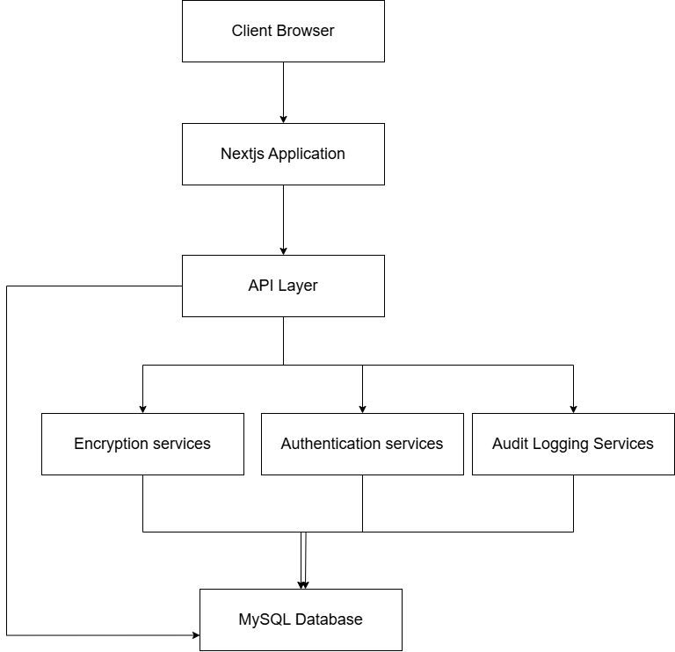
Figure 4 System Architecture

System Description
The Secure Customer Data Management System represents a comprehensive solution designed to address the critical challenges of customer privacy and data protection in microfinance institutions. This system integrates robust security measures with efficient operational functionality to safeguard sensitive customer information while enabling authorized access for legitimate business purposes.
System Architecture
The system employs a multi-layered architecture designed for security, scalability, and performance. At its foundation is a four-tier structure consisting of:
1. Client Layer: A browser-based interface providing responsive design for various devices, incorporating client-side validation and security measures. This layer ensures accessibility while implementing the first line of defense against malicious inputs.
2. Frontend Layer: Built on Next.js, this layer leverages server-side rendering for enhanced security, reducing client-side vulnerabilities. It implements role-based UI components that dynamically adjust based on user permissions, ensuring users only see interface elements relevant to their authorized functions.
3. Application Layer: The core processing tier houses the business logic, authentication services, encryption mechanisms, and audit logging functionality. This layer enforces security policies, manages user sessions, and handles all data transformations before storage or retrieval.
4. Data Layer: The foundation of the system utilizes MySQL with field-level encryption for sensitive data. This layer implements strict access controls and maintains comprehensive backup and recovery mechanisms to ensure data integrity and availability.

The architecture follows a "defense in depth" strategy, with multiple security controls at each layer. This approach ensures that a failure at one level doesn't compromise the entire system, significantly reducing the risk of unauthorized access or data breaches.

Security Features
The system's security capabilities represent its most critical aspect, implementing multiple protective measures:
1. Data Encryption: All sensitive customer data is protected using AES-256 encryption in CBC mode, the industry standard for financial information. The system implements field-level encryption, targeting specific sensitive attributes like social security numbers and account details while leaving non-sensitive data unencrypted for performance optimization. Encryption keys are securely managed through environmental variables with regular rotation procedures.
2. Role-Based Access Control (RBAC): A sophisticated permission system restricts data access based on job function and need-to-know principles. Three primary roles—Admin, Staff, and Customer—have carefully defined permission sets. Admins can manage users and system settings; Staff have limited access to customer data with additional logging for sensitive information; Customers can only access their own information. The RBAC implementation uses JWT-based authentication with role information embedded in tokens, session timeouts, and server-side validation of all access attempts.
3. Comprehensive Audit Logging: Every significant action within the system is recorded in immutable audit logs, creating a detailed trail of who accessed what data, when, and for what purpose. The logging system captures authentication events, data access, modifications, and privacy-related activities. Each log entry contains user identification, timestamp, action details, and contextual information. The system implements real-time alerts for suspicious patterns and maintains logs for a minimum of two years.
4. Privacy Management Portal: A dedicated interface allows customers to exercise their data privacy rights. This portal provides transparency about data usage, enables customers to manage consent preferences, and facilitates requests for data access, correction, or deletion. The portal implements a structured workflow for handling privacy requests with clear status tracking and completion notifications.

Functional Capabilities
Beyond security, the system delivers essential operational functionality:
1. Customer Data Management: Comprehensive tools for storing, retrieving, and managing customer information throughout its lifecycle. The system maintains customer profiles, transaction histories, and account details with appropriate access controls and data quality measures.
2. User Administration: Administrative interfaces for managing system users, including creation, role assignment, status changes, and access reviews. The system enforces separation of duties for administrative functions and implements approval workflows for sensitive changes.
3. Training Module Management: Tools for assigning, tracking, and evaluating staff completion of required privacy and security training. The system maintains records of training completion, quiz scores, and certification status, with automated notifications for approaching deadlines.
4. Reporting and Analytics: Capabilities for generating compliance reports, security metrics, and operational insights while maintaining appropriate data protection. The system implements privacy-preserving analytics techniques to minimize exposure of sensitive information during reporting activities.

Technical Implementation
The system is built using modern technologies selected for security, performance, and maintainability:
1. Development Stack: The frontend utilizes React with TypeScript for type safety, while the backend employs Node.js with a focus on server-side rendering for security. The database layer uses MySQL with appropriate indexing and optimization for performance.
2. Security Implementation: Authentication uses JWT with secure storage and transmission practices. Encryption utilizes the Node.js crypto module with proper initialization vector management. Access control combines middleware checks with component-level permissions.
3. Deployment Environment: The system runs on Linux servers with hardened configurations, deployed behind properly configured firewalls with network segmentation. All communications use TLS 1.3 for data in transit protection.

UML Class diagram
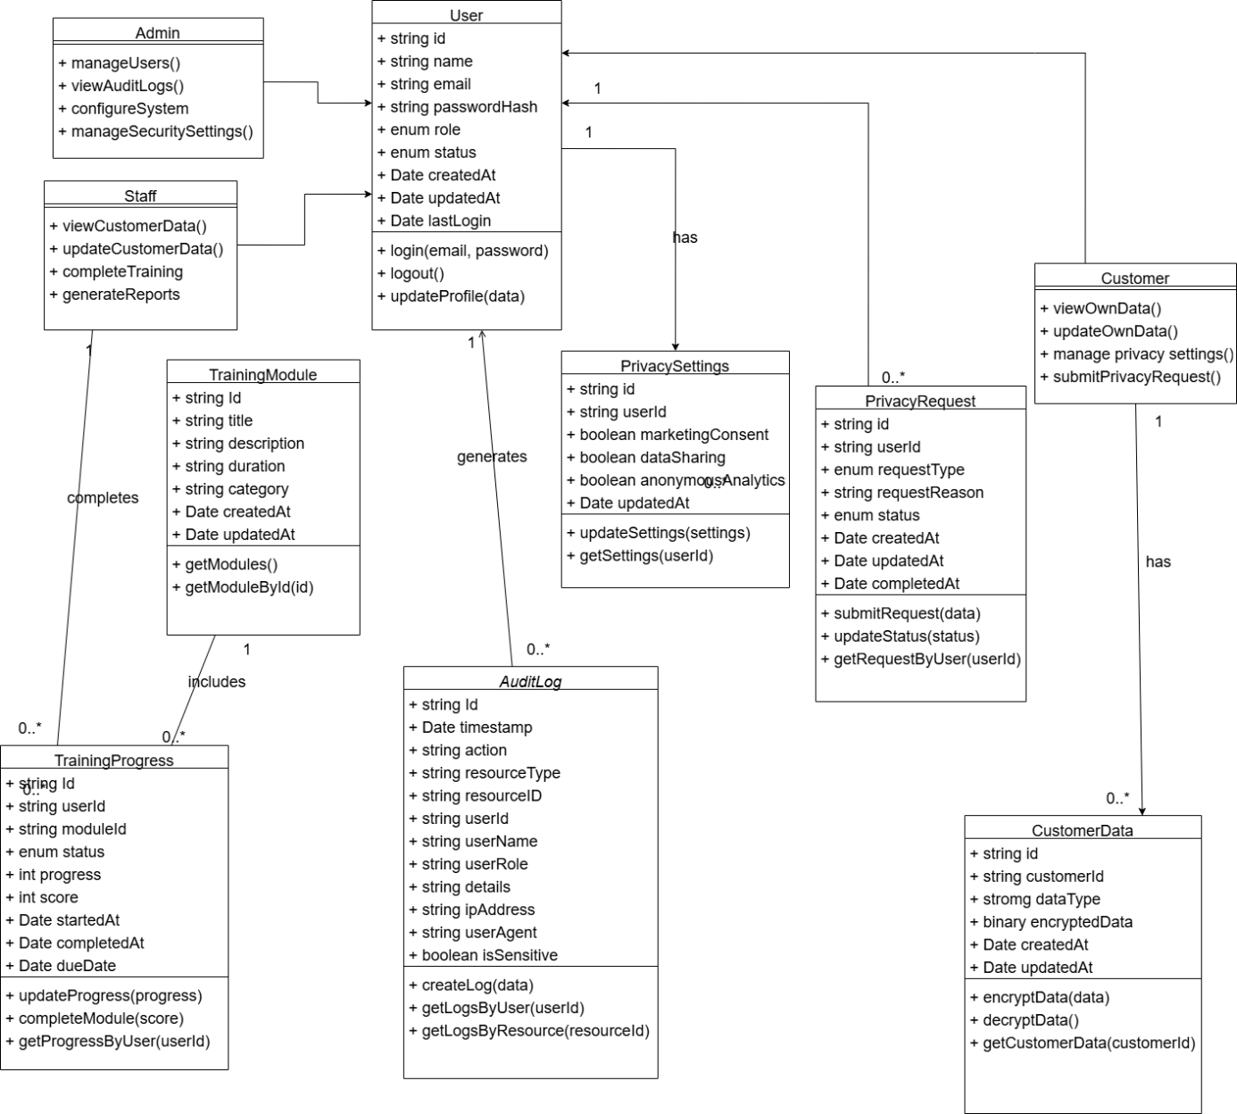
Figure 5 UML Class Diagram
1. User Roles and System Access
The system supports three primary roles derived from the User entity:
- Admin
- Staff
- Customer
Each user role is tied to different levels of permissions and system functions.
1.1 Admin
Admins have elevated privileges to oversee and configure the platform. Their core responsibilities include:
manageUsers(): Admins can create, update, or delete user accounts.
viewAuditLogs(): They can access detailed audit trails of user activity.
configureSystem(): Enables admins to set global configurations, including security policies.
manageSecuritySettings(): Allows adjustments to encryption keys, password policies, and authentication mechanisms.
Admins are a critical part of enforcing data governance policies and monitoring systemic behavior.
1.2 Staff
Staff members interact primarily with customer data and internal reporting tools:
viewCustomerData() and updateCustomerData(): These operations allow authorized personnel to handle encrypted customer records.
completeTraining(): Staff must complete data protection and cybersecurity training modules.
generateReports(): Enables extraction of operational or compliance reports.
By enforcing training, the system ensures data handling is restricted to informed personnel.
1.3 Customer
Customers are granted autonomy over their data:
viewOwnData() and updateOwnData(): Lets customers access or modify their profile or transactional data.
managePrivacySettings(): Customers set preferences related to data sharing and analytics.
submitPrivacyRequest(): This operation allows them to request data deletion or rectification under privacy laws.
2. Core Classes and Functional Entities
2.1 User
The User class is the central actor in the system. Attributes include:
role: Determines access privileges (Admin, Staff, or Customer).
status: Active, suspended, or archived.
createdAt, updatedAt, lastLogin: Timestamp fields for auditing and activity monitoring.
Methods include:
login(email, password) and logout(): Authenticate and terminate sessions.
updateProfile(data): Modify personal data, subject to access control policies.
2.2 Privacy Settings
This class records user preferences for data usage:
marketingConsent: Whether the user consents to receive marketing content.
dataSharing: Permission for data to be shared with third parties.
anonymousAnalytics: Consent for data to be used in anonymized statistical studies.
Methods:
updateSettings(settings): Staff or customers can update settings
getSettings(userId): Used to retrieve preferences, e.g., during targeted outreach.
These settings help align with GDPR principles like data minimization and purpose limitation.
2.3 Privacy Request
Customers use this feature to exercise their data rights:
requestType: Types include access, correction, deletion, or objection.
requestReason: Justification for request.
status: Pending, approved, denied.
Methods:
submitRequest(data), updateStatus(status), and getRequestByUser(userId) allow tracking and processing of these privacy-related actions.
This feature ensures compliance with legal frameworks such as Law No. 2010/012 and GDPR.
3. Data Security and Logging
3.1 CustomerData
This is the repository of encrypted personal information:
dataType: Classifies the data (e.g., financial, biometric, demographic).
encryptedData: Stored in binary form using AES encryption.
Methods:
encryptData(data) and decryptData(): Ensures that raw data is never exposed.
getCustomerData(customerId): Used by authorized actors to retrieve and process data.
The encryption implementation ensures confidentiality, integrity, and authenticity.
3.2 AuditLog
The AuditLog class maintains accountability by tracking actions across the platform:
timestamp, action, resourceType, resourceId: Record what occurred and where.
userId, userRole, userAgent: Identify who initiated the action.
isSensitive: Flags critical operations for closer monitoring.
Methods:
createLog(data): Automatically triggered by system events.
getLogsByUser(userId) and getLogsByResource(resourceId): Allows for targeted audits.
Audit logs are essential for forensics, compliance, and incident response.
4. Training and Capacity Building
4.1 TrainingModule
This component provides mandatory and elective training to staff:
title, duration, category: Metadata about the training.
getModules() and getModuleById(): Retrieve learning materials.
Training modules ensure staff understand data privacy laws, secure handling techniques, and institutional policies.
4.2 TrainingProgress
Tracks user performance on training modules:
status: Not started, in progress, completed.
score: Quantifies comprehension.
startedAt, completedAt, dueDate: Ensure adherence to learning timelines.
Methods:
updateProgress(progress) and getProgressByUser(userId): Facilitate analytics and HR monitoring.
By integrating training and tracking, the system promotes a culture of continuous security awareness.
5. Relationships and Data Flow
The diagram reflects a modular and secure system where:
Each User has PrivacySettings and may submit multiple PrivacyRequests.
Staff and Admin interact with CustomerData, which is encrypted and logged.
All actions on sensitive data trigger entries in AuditLog.
Staff are required to complete TrainingModules, which are tracked via TrainingProgress.
This structure reinforces least privilege principles, segmentation of duties, and traceability.
6. Compliance and Policy Integration
The architecture is informed by multiple compliance standards:
GDPR: User consent, data minimization, data portability.
Law No. 2010/012: Electronic communication confidentiality.
ISO 27001: Logging, role-based access, secure software development.
Integration with these policies is evident in audit logging, privacy request tracking, and encrypted data storage.
Use Case Diagram
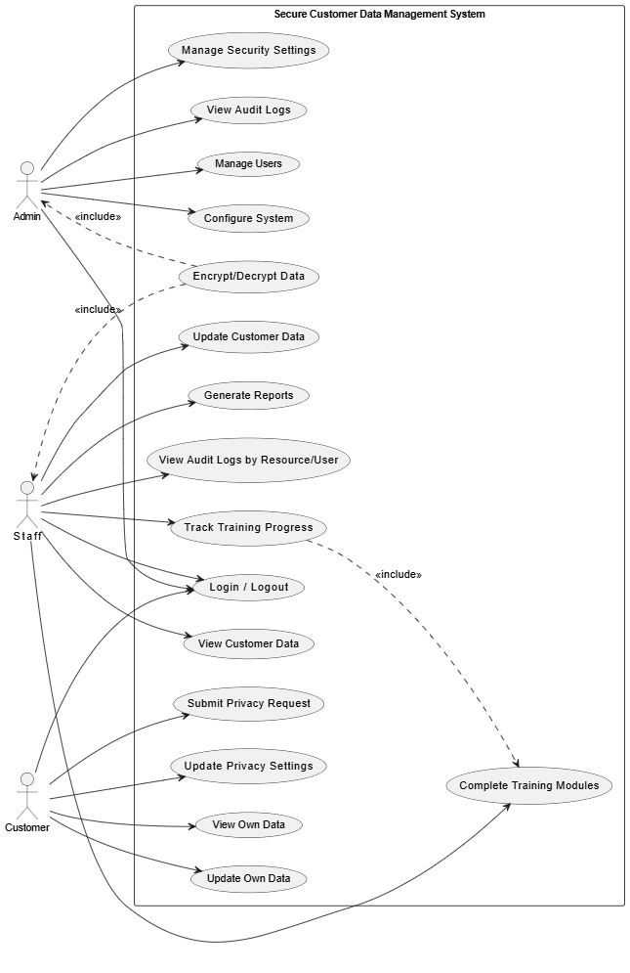
Figure 6 Use Case Diagram

Core Functionalities
1. Security Management
- Manage Security Settings: Allows administrators to configure system-wide security parameters including password policies, multi-factor authentication requirements, and session timeouts.
- Encrypt/Decrypt Data: Provides cryptographic operations to protect sensitive customer data both at rest and in transit, ensuring compliance with regulations like GDPR and CCPA.
- View Audit Logs: Enables security teams to monitor all system activities, tracking who accessed what data and when, crucial for compliance and incident investigations.
- View Audit Logs by Resource/User: Offers granular auditing capabilities to filter logs by specific resources or users, facilitating targeted security reviews.
2. User Management
- Manage Users: Administrators can create, modify, and deactivate user accounts while assigning appropriate roles and permissions based on the principle of least privilege.
- Track Training Progress: Ensures all personnel complete mandatory security and privacy training before accessing sensitive data, maintaining organizational compliance standards.
- Complete Training Modules: Employees fulfill compliance requirements by completing interactive training on data handling best practices and regulatory obligations.
3. Data Operations
- Update Customer Data: Authorized staff can modify customer records while all changes are automatically logged for audit purposes.
- View Customer Data: Role-based access controls determine which users can see specific data fields, preventing unnecessary exposure of sensitive information.
- Generate Reports: Creates standardized or custom reports from customer data while automatically redacting sensitive elements based on the viewer's permissions.
4. Privacy Compliance
- Submit Privacy Request: Customers can exercise their data rights (access, deletion, correction) through automated workflows that route requests to appropriate teams.
- Update Privacy Settings: Customers control their communication preferences and data sharing consents through self-service portals.
- View Own Data: Provides customers transparent access to all personal information stored in the system, building trust and enabling data accuracy verification.
- Update Own Data: Allows customers to maintain their own profile information through secure self-service channels, reducing administrative overhead.
5. System Administration
- Configure System: Technical administrators can adjust system parameters, integrate with external services, and manage infrastructure components.
- Login/Logout: Secure authentication processes govern all system access, with session management protecting against unauthorized use.
Business Value and Compliance
This system delivers significant value by:
- Reducing Risk: Comprehensive security controls and auditing minimize data breach risks and associated financial/reputational damage.
- Ensuring Compliance: Built-in features support adherence to GDPR, CCPA, HIPAA, and other privacy regulations through consent management, data subject rights processing, and audit capabilities.
- Operational Efficiency: Automated workflows for privacy requests and customer data updates reduce manual processing while improving accuracy.
- Customer Trust: Transparent data practices and self-service options enhance customer relationships and brand reputation.
User Roles and Access
The system implements role-based access control (RBAC) with typical roles including:
- Security Officers: Manage encryption, audit logs, and security configurations
- Administrators: Handle user management and system configuration
- Customer Service: Update customer data with appropriate oversight
- Customers: Access and control their own personal information
- Compliance Teams: Monitor training completion and audit trails
Technical Implementation
While the image doesn't specify technical details, such a system would typically involve:
- Database encryption (AES-256 for data at rest, TLS 1.2+ for data in transit)
- Role-based access control matrix
- Immutable audit logging
- Automated privacy request workflows
- Secure API integrations
- Regular penetration testing and vulnerability scanning

4.3 Database Design
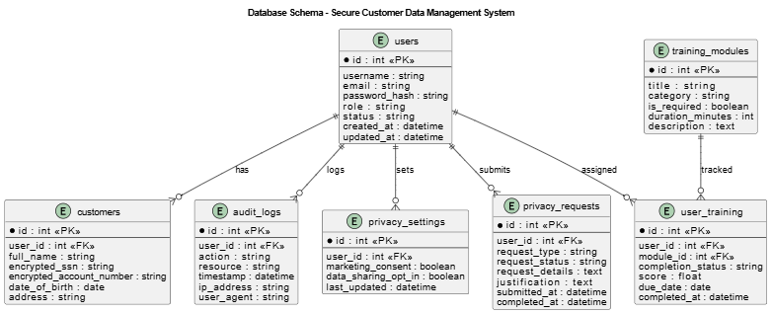
Figure 7 ER Diagram

Database Schema
The database schema includes the following tables:
- Users
- Primary table for all user accounts.
- Contains authentication and role information.
- Stores basic user details and status.
- Customers
- Stores customer-specific information.
- Contains encrypted sensitive data (SSN, account numbers)
- Linked to user accounts.
- audit_logs
- Comprehensive logging of all system activities.
- Records user actions, timestamps, and affected resources.
- Stores IP addresses and user agents for security analysis.

- privacy_settings
- User-specific privacy preferences.
- Marketing consent and data sharing options.
- Timestamp for last update.
- privacy_requests
- Tracks data subject requests (access, correction, deletion)
- Maintains status and completion information.
- Stores request details and justifications.
- training_modules
- Defines available training content.
- Categorizes modules as required or optional.
- Includes duration and description information.
- user_training
- Tracks user progress through training modules.
- Records completion status and scores.
- Manages due dates for required training.

Indexes and Constraints
- Foreign key constraints ensure data integrity
- Indexes on frequently queried columns for performance
- Unique constraints on email addresses and other unique identifiers
- Composite indexes for common query patterns

4.4 Data Encryption Strategy (AES Implementation)
The system implements AES-256 encryption for sensitive customer data, following industry best practices for financial information protection.
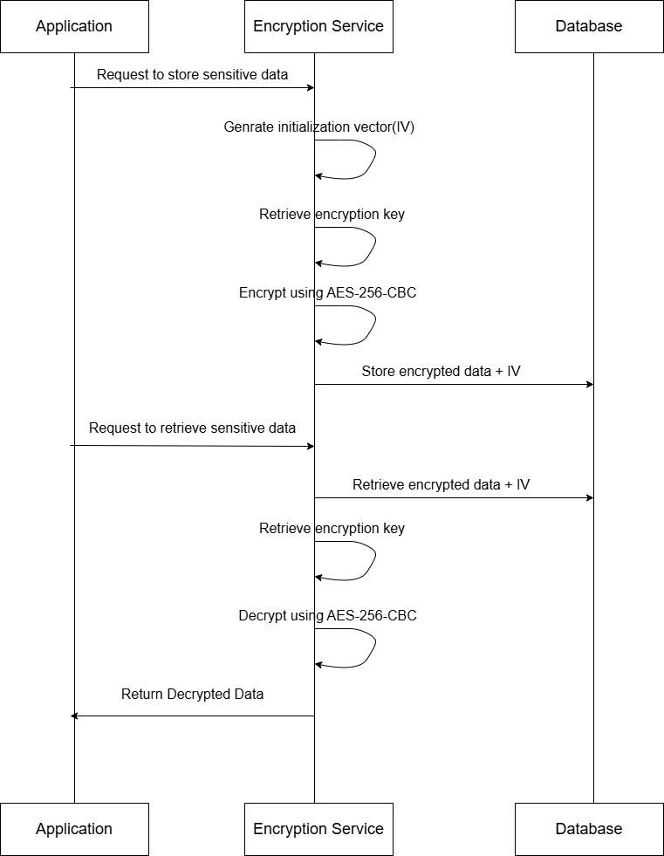
Figure 8 Data Encryption Sequence diagram

Implementation Details
- Encryption Algorithm: AES-256 in CBC mode
- Key Management:
- Encryption keys stored in environment variables.
- Key rotation capabilities built into the system.
- Separate keys for different data categories.
- Field-Level Encryption:
- Sensitive fields encrypted individually.
- Non-sensitive fields stored in plaintext for performance.
- Encrypted fields include:
- Social Security Numbers (SSN)
- Account numbers
- Other personally identifiable information (PII)
- Algorithm
Encryption Function (encryptData)
- Generate a random 16-byte IV.
- Read 256-bit encryption key from environment variable ENCRYPTION_KEY and convert to buffer.
- Create an AES-256-CBC cipher using the key and IV.
- Encrypt the data:
  - Call cipher.update() with plain text.
  - Call cipher.final() to complete encryption.
- Combine IV and encrypted text (as hex strings) separated by a colon (:).
- Return the result.
Decryption Function (decryptData)
- Split the encryptedData string at the colon (:) to extract ivHex and encryptedHex.
- Convert ivHex to buffer.
- Read and convert the encryption key again from ENCRYPTION_KEY.
- Create an AES-256-CBC decipher using the same key and IV.
- Decrypt the ciphertext:
  - Call decipher.update() with the encrypted data.
  - Call decipher.final() to complete decryption.
- Return the decrypted plaintext.

- Database Storage:
- Encrypted data stored as binary (VARBINARY)
- Initialization vectors stored alongside encrypted data.
- Indexes on non-encrypted fields only.
- Security Considerations:
- No encryption keys in source code.
- Encryption performed server-side only.
- Memory cleared after encryption/decryption operations.
- Key rotation procedures documented and implemented.

4.5 Role-Based Access Control (RBAC) Design
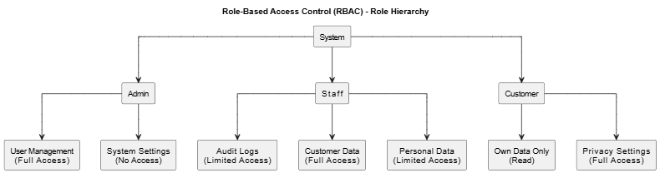
Figure 9 RBAC design
Role Definitions
- Admin
- System administrators with full access.
- Can manage users, view all data, and configure system settings.
- Access to audit logs and security settings.
- Can view sensitive customer data with proper logging.
- Staff
- Regular employees who work with customer data.
- Limited access based on job requirements.
- Cannot access system settings or user management.
- Access to sensitive data is logged and requires justification.
- Required to complete privacy training.
- Customer
- End users of the system.
- Access only to their own data.
- Can manage privacy settings and submit data requests.
- Cannot access other customers' data or system functions.
Permission Matrix
Resource | Admin | Staff | Customer
User Management | Create, Read, Update, delete | None | None
Audit Logs | Full Access | Limited (own actions) | Limited (own data access)
Customer Data | Full Access | Read, Limited Update | Own data only
Sensitive Data | Full Access (logged) | Limited Access (logged) | Own data only
Table 1 Permission Matrix
Implementation
- Authentication:
- JWT-based authentication.
- Session management with timeouts.
- Role information stored in tokens.
- Authorization:
- Role checks on all API routes.
- UI components conditionally rendered based on roles.
- Server-side validation of permissions.
- Flow Chart (Role-based Route Protection):
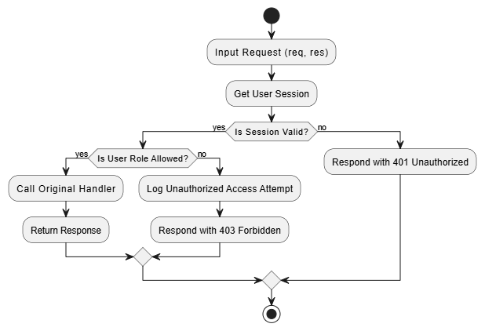
Figure 10 Role-based Route Protection Flow Chart

4.6 Audit Logging Design
Audit Log Structure
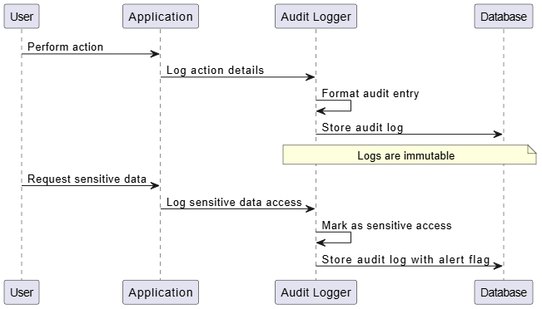
Figure 11 Audit Logging Flow

Audit Log Fields
Each audit log entry contains:
- Basic Information:
- Unique log ID
- Timestamp (in UTC)
- User ID and name
- User role
- IP address
- User agent
- Action Details:
- Action type (VIEW, UPDATE, DELETE, etc.)
- Resource type (CUSTOMER, SYSTEM, etc.)
- Resource ID
- Detailed description
- Sensitivity Flags:
- Whether sensitive data was accessed
- Justification for access (if provided)
- Alert level (normal, warning, critical)
Audit Log Types
- Authentication Events:
- Successful logins
- Failed Login attempts
- Password changes
- Account lockouts

- Data Access Events:
- Customer data views
- Sensitive data access
- Data exports
- Search operations
- Data Modification Events:
- Customer data updates
- System setting changes
- User account modifications
- Privacy-Related Events:
- Privacy setting changes
- Data subject requests
- Data deletion operations

Algorithm: Audit Log Creation
- Function Definition:
  - Define an asynchronous function createAuditLog that accepts an object with parameters:
    - action
    - resourceType
    - resourceId
    - userId
    - userName
    - userRole
    - details
    - ipAddress (default: "127.0.0.1")
    - userAgent (default: "Unknown")
    - isSensitive (default: false)
- Generate Timestamp and ID:
  - Create a timestamp using new Date().toISOString().
  - Generate a unique ID using crypto.randomUUID().
- Create Log Entry:
  - Construct a log entry object logEntry with all the provided parameters and generated values.
- Store Log Entry in Database:
  - Execute a database query to insert the log entry into the audit_logs table with the following fields:
    - id
    - timestamp
    - action
    - resource_type
    - resource_id
    - user_id
    - user_name
    - user_role
    - details
    - ip_address
    - user_agent
    - is_sensitive (convert boolean to integer: 1 for true, 0 for false)
- Check for Sensitive Data:
  - If isSensitive is true:
    - Call triggerSensitiveDataAlert with the logEntry as a parameter.

Security Monitoring
- Real-time Alerts:
- Unusual access patterns
- Multiple failed login attempts
- Sensitive data access outside normal hours
- Bulk data exports
- Reporting:
- Daily/weekly security summaries
- Compliance reports for regulations
- User activity reports
- Retention:
- Audit logs retained for minimum of 2 years
- Immutable storage to prevent tampering
- Backup procedures for audit trail

4.7 Privacy Portal Design

User Journey
- Privacy Dashboard:
- Overview of privacy status
- Recent activity related to user's data
- Pending data requests status
- Privacy rights information
- Privacy Settings Management:
- Marketing consent toggles
- Third-party data sharing options
- Analytics participation settings
- Communication preferences
- Data Subject Request Workflow:
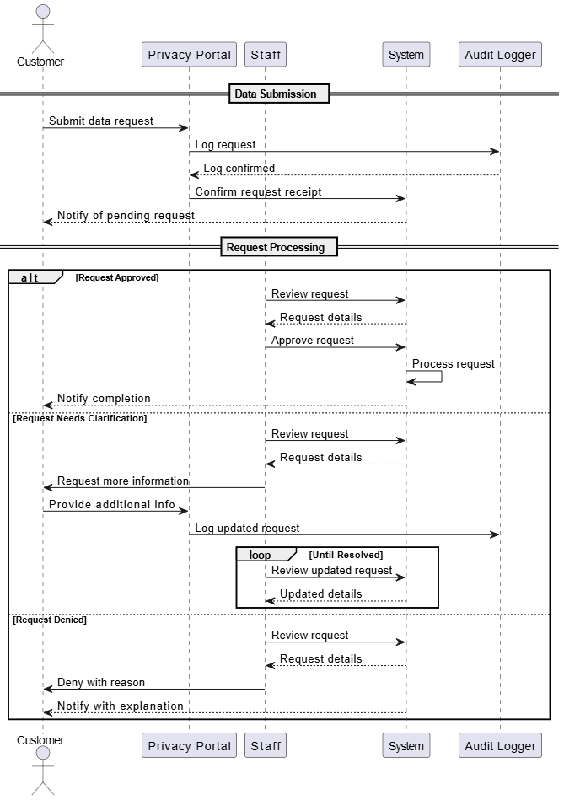
Figure 12 Data Subject Request Workflow
Implementation Details
- Privacy Settings Component:
- Real-time updates to database
- Audit logging of all changes
- Clear explanations of each setting
- Data Request Form:
- Structured request submission
- Type selection (access, correction, deletion)
- Reason field for context
- Attachment capability for supporting documents
- Access Log Viewer:
- Transparent view of who accessed user data
- Filtering by date, staff member, and data type
- Explanations for why data was accessed
- Algorithm: Update Privacy Settings:
- Function Definition:
  - Define an asynchronous function updatePrivacySettings that accepts:
    - userId: A string representing the user's ID.
    - settings: An object containing optional privacy settings:
      - marketingConsent (boolean)
      - dataSharing (boolean)
      - anonymousAnalytics (boolean)
- Initialize Variables:
  - Create an empty array updateFields to hold the SQL update statements.
  - Create an empty array values to hold the corresponding values for the SQL query.
- Check and Add Marketing Consent:
  - If settings.marketingConsent is defined:
    - Push 'marketing_consent = ?' to updateFields.
    - Push 1 if settings.marketingConsent is true, otherwise push 0 to values.
- Check and Add Data Sharing:
  - If settings.dataSharing is defined:
    - Push 'data_sharing = ?' to updateFields.
    - Push 1 if settings.dataSharing is true, otherwise push 0 to values.
- Check and Add Anonymous Analytics:
  - If settings.anonymousAnalytics is defined:
    - Push 'anonymous_analytics = ?' to updateFields.
    - Push 1 if settings.anonymousAnalytics is true, otherwise push 0 to values.
- Check for Updates:
  - If updateFields is empty (no settings were defined):
    - Return false.
- Add Timestamp and User ID:
  - Push 'updated_at = ?' to updateFields.
  - Push the current timestamp (in ISO format) to values.
  - Push userId to values.
- Construct SQL Query:
  - Create a SQL update query string using the updateFields array.
- Execute SQL Query:
  - Call executeQuery with the constructed query and values.
- Log the Change:
  - Call createAuditLog with the following parameters:
    - action: 'UPDATE_PRIVACY_SETTINGS'
    - resourceType: 'PRIVACY_SETTINGS'
    - resourceId: userId
    - userId: userId
    - userName: 'Customer' (this should be replaced with the actual user name)
    - userRole: 'customer'
    - details: A string containing the updated settings in JSON format.
- Return Success:
  - Return true to indicate that the update was successful.

Compliance Features
- Right to Access:
- Complete data export in machine-readable format
- Clear explanations of data usage
- Processing timelines within regulatory requirements
- Right to Rectification:
- Structured correction request process
- Verification of changes
- Notification of completion
- Right to Erasure:
- Clear deletion request workflow
- Explanation of retention requirements
- Verification of deletion
- Right to Object:
- Granular consent management
- Easy opt-out mechanisms
- Clear consequences of opting out

4.8 Findings
This section presents the key findings from the assessment of CCC Plc's data protection practices, based on the analysis of survey data, interviews, and technical evaluation. The findings are organized into thematic areas to provide a comprehensive understanding of the current state of customer privacy and data protection at the institution.

4.8.1 Current State of Data Protection Measures
Staff Awareness and Practices
Survey Results
The survey of about 50 staff members across different departments revealed important insights into awareness levels and practices:
- General Awareness: Staff demonstrated varying levels of awareness regarding data protection:
- 68% of respondents were not aware of the laws and regulations related to data protection that apply to their institution.
- 90% of respondents are aware of their institutions data privacy and protection policies.
- 90% of respondents reported to know the type of customer data that are considered sensitive and require strict protection

- Training and Education: The survey highlighted gaps in security training:
- 30% of respondents reported to receive formal training on data privacy and protection regularly.
- 56% of respondents reported receiving no formal training on data privacy and protection.
- 82% expressed interest in receiving more comprehensive security training.

- Security Practices: Actual security practices among staff revealed concerning patterns:
- 70% reported using personal devices to access customer information.

Interview Findings
In-depth interviews with 10 key staff members provided additional qualitative insights:
- Operational Challenges: Employees noted several operational issues that have an impact on data protection.
- Security shortcuts were frequently caused by system performance concerns.
- A heavy workload during busy times caused people to pay less attention to security procedures.
- Stronger controls were difficult to adopt due to outdated systems' technical constraints; pressure to serve clients promptly occasionally clashed with security considerations.
- Resource Constraints: Staff highlighted resource limitations impacting data protection:
- Insufficient IT personnel dedicated to security functions.
- Limited budget allocation for security tools and technologies
- Inadequate time allocation for security training and awareness activities
- Competing priorities for investment in infrastructure upgrades

Physical Security:
Evaluation of physical security measures revealed:
1. Adequate controls for server room access
2. Continuous monitoring of physical access to sensitive areas
3. Proper disposal of physical documents containing customer information

4.9 System’s User Manual
Introduction
The Secure Microfinance System is a comprehensive platform designed to manage customer data with enterprise-grade security for microfinance institutions. The system ensures the protection of sensitive customer information through encryption, role-based access control, comprehensive audit logging, and privacy management features.
This user manual provides detailed instructions for all users of the system, including administrators, staff members, and customers. It covers all aspects of the system from basic navigation to advanced security features.
Getting Started
System Requirements
To access the Secure Microfinance System, you need:
- A modern web browser (Chrome, Firefox, Safari, or Edge - latest versions recommended)
- Internet connection
- Screen resolution of at least 1280x720 pixels
- JavaScript enabled in your browser

Accessing the System
- Open your web browser
- Enter the system URL provided by your organization
- The system login page will appear
As shown in the screenshot below
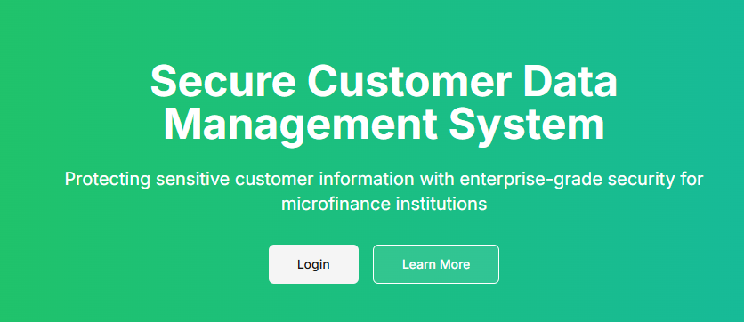
Login Process
- On the login page, enter your email address and password
- Click the "Login" button
- For security reasons, after 5 unsuccessful login attempts, your account will be temporarily locked
Demo Accounts (for testing only):
- Admin: [admin@example.com](mailto:admin@example.com) / password
- Staff: [staff@example.com](mailto:staff@example.com) / password
- Customer: [customer@example.com](mailto:customer@example.com) / password
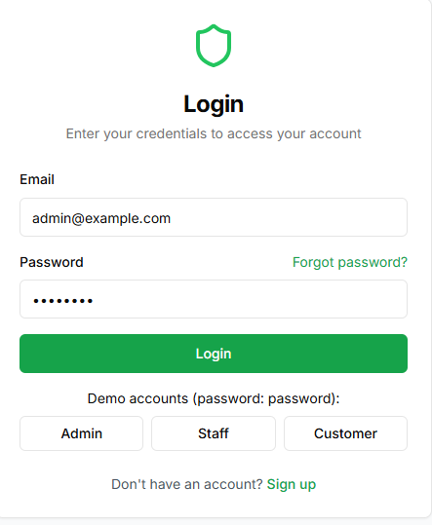
Dashboard Overview
After successful login, you will be directed to your dashboard. The dashboard displays:
- Welcome message with your name and role
- System status information
- Recent notifications
- Quick access cards to frequently used features
- Navigation menu on the left side
The dashboard is personalized based on your user role, showing only the features and information relevant to your permissions.
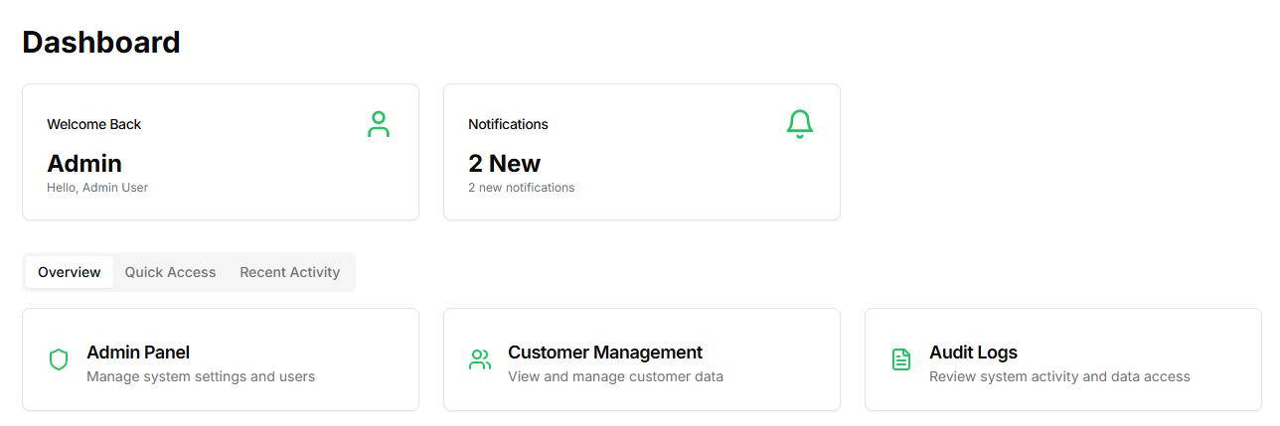
User Roles and Permissions
Admin Role
Administrators have full access to the system and are responsible for:
- Managing user accounts
- Configuring system settings
- Monitoring security
- Reviewing audit logs
- Managing encryption keys
- Overseeing compliance
Staff Role
Staff members have limited access focused on customer service:
- Viewing and managing customer data
- Completing required privacy and security training
- Generating reports
- Limited access to sensitive customer information
Customer Role
Customers can access and manage their own information:
- Viewing their personal profile
- Managing privacy preferences
- Submitting data access, correction, or deletion requests
- Viewing their data access history

Admin User Guide
User Management
Viewing All Users
- Navigate to "Admin" → "User Management" from the main menu
- The system displays a list of all users with their basic information
- Use the search box to find specific users by name or email
- Use filters to view users by role or status
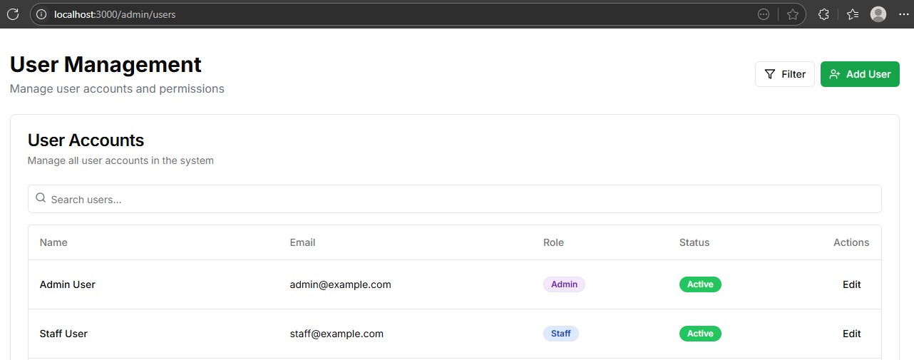
Adding a New User
- From the User Management page, click "Add User"
- Fill in the required fields:
- Full Name
- Email Address
- Role (Admin, Staff, or Customer)
- Initial Password
- Click "Create User"
- The system will send an email to the new user with login instructions
Approving Staff Accounts
- Navigate to "Admin" → "User Management"
- Filter the list to show "Pending" accounts
- Review each pending account
- Click "Approve" or "Reject" as appropriate
- Add a note explaining your decision if rejecting an account

Security Settings
Password Policy Configuration
- Navigate to "Admin" → "Security Settings"
- Under "Password Policy," configure:
- Minimum password length
- Required character types
- Password expiration period
- Account lockout threshold
- Click "Save Changes"

Two-Factor Authentication Setup
- Navigate to "Admin" → "Security Settings"
- Under "Two-Factor Authentication," select which roles require 2FA
- Choose authentication methods (SMS, email, authenticator app)
- Click "Save Changes"

Audit Logs
Viewing Audit Logs
- Navigate to "Admin" → "Audit Logs"
- The system displays a chronological list of all system activities
- Use filters to narrow down logs by:
- Date range
- User
- Action type
- Resource type
- Click on any log entry to view detailed information

Exporting Audit Logs
- Navigate to "Admin" → "Audit Logs"
- Apply any desired filters
- Click "Export Logs"
- Choose the export format (CSV, PDF, or JSON)
- Click "Download”

System Configuration
Database Settings
- Navigate to "Admin" → "System Settings" → "Database"
- View current database status and performance metrics
- Configure backup schedule and retention policies
- Click "Save Changes"

Email Configuration
- Navigate to "Admin" → "System Settings" → "Email"
- Configure SMTP server settings
- Set up email templates for system notifications
- Test the configuration by sending a test email
- Click "Save Changes"

Staff User Guide
Customer Management
Viewing Customer List
- Navigate to "Customers" from the main menu
- The system displays a list of all customers with basic information
- Use the search box to find specific customers
- Use filters to narrow down the list

Viewing Customer Details
- From the customer list, click on a customer's name
- The system displays the customer's profile with tabs for different information categories
- Navigate between tabs to view different types of information

Accessing Sensitive Data
- From a customer's profile, locate the sensitive information section
- Click "Show Sensitive Data"
- The system will log this access and may require additional authentication
- A warning message appears reminding you of security policies
- View the sensitive information
- Click "Hide Sensitive Data" when finished

Handling Sensitive Data
Security Guidelines
When working with sensitive customer data:
- Always ensure your screen is not visible to unauthorized individuals
- Never share your login credentials
- Lock your computer when stepping away
- Do not copy sensitive data to unauthorized locations
- Report any security concerns immediately

Exporting Customer Data
- Navigate to the customer's profile
- Click "Export Data"
- Select which data categories to include
- Provide a reason for the export (will be logged)
- Click "Generate Export"
- The system will create an encrypted file for download

Required Training
Viewing Assigned Training
- Navigate to "Training" from the main menu
- The system displays all assigned training modules with their status
- Required modules are marked with a "Required" badge
- Check due dates for each module

Completing a Training Module
- From the training list, click "Start" or "Continue" on a module
- Read through the training material
- Complete any interactive exercises
- Take the quiz at the end of the module
- You must score at least 80% to pass
- If you fail, review the material and retake the quiz

Generating Reports
Creating a Customer Report
- Navigate to "Reports" from the main menu
- Click "New Report"
- Select "Customer Report" as the report type
- Choose the data fields to include
- Set filters if needed
- Click "Generate Report"
- The system will create the report and allow you to download it

Customer User Guide
Viewing Your Profile
- After logging in, click on "Profile" in the navigation menu
- Your profile page displays your personal information
- To update any information, click "Edit Profile"
- Make the necessary changes and click "Save"

Privacy Portal
Accessing the Privacy Portal
- Navigate to "Privacy Portal" from the main menu
- The portal displays an overview of your privacy rights and settings
- Use the tabs to navigate between different sections
Managing Privacy Settings
- In the Privacy Portal, click on the "Privacy Settings" tab
- Toggle switches to update your preferences for:
- Marketing communications
- Third-party data sharing
- Anonymous analytics
- Click "Save Preferences" to update your settings

Submitting Data Requests
Requesting Data Access
- In the Privacy Portal, click on the "Data Requests" tab
- Click on "Data Access" option
- Provide a reason for your request in the text field.
- Click "Submit Request"
- The system will process your request within 30 days.

Requesting Data Correction
- In the Privacy Portal, click on the "Data Requests" tab.
- Click on "Data Correction" option.
- Specify which information needs correction.
- Provide the correct information.
- Click "Submit Request"

Requesting Data Deletion
- In the Privacy Portal, click on the "Data Requests" tab.
- Click on "Data Deletion" option.
- Provide a reason for your request.
- Click "Submit Request"
- Note that some data may need to be retained for legal or regulatory purposes.

Security Features
Data Encryption
The system uses AES-256 encryption for all sensitive customer data. This ensures that even if unauthorized access occurs, the data remains protected.
Key security measures include:
- Encryption of sensitive data at rest
- Secure transmission using TLS/SSL
- Secure key management
- Regular encryption key rotation

Audit Logging
All actions in the system are logged for security and compliance purposes:
- User logins and logouts
- Data access events
- Changes to customer information
- Access to sensitive data
- Privacy setting changes
- Data exports

Audit logs include:
- Timestamp
- User information
- Action performed.
- Affected resources.
- IP address
- User agent (browser/device)

Access Controls
The system implements strict role-based access control:
- Users can only access information necessary for their role
- Sensitive data requires additional authorization.
- Failed login attempts are monitored.
- Inactive sessions are automatically terminated.
- Regular access reviews are conducted.

Security Best Practices
All users should follow these best security practices:
- Use strong, unique passwords.
- Enable two-factor authentication if available.
- Never share login credentials
- Log out when finished using the system.
- Report suspicious activities.
- Complete security training promptly
- Keep your device and browser updated.

Conclusion:
The chapter concludes by synthesizing the findings from staff surveys, interviews, physical security audits, and technical evaluations, revealing strengths and weaknesses in CCC Plc’s data protection framework. While fundamental security measures exist, significant gaps in awareness, training, infrastructure, and regulatory adherence remain. The implemented system offers a scalable, compliant, and secure model that can serve as a benchmark for CCC Plc and similar institutions, emphasizing that effective data protection integrates both technical controls and organizational reforms.

Chapter 5: Summary, Conclusions, Discussion, and Recommendations

This final chapter encapsulates the study’s core findings regarding customer privacy and data protection in microfinance, particularly at CCC Plc. It discusses the implications of these findings for cybersecurity practices, regulatory compliance, and sustainable financial inclusion. Reflecting on the study’s contributions and limitations, it paves the way for future research and practical enhancements. It also presents actionable recommendations aimed at improving the technical, organizational, customer-focused, and regulatory aspects of data protection in MFIs.

5.1 Summary of Findings
This study examined the data protection and customer privacy policies of CCC Plc, a Cameroonian microfinance organization, to assess existing policies and pinpoint areas in need of development. To collect thorough information about the organization's data protection procedures, the study used a mixed-methods approach, combining quantitative surveys with qualitative interviews. The following is a summary of the main conclusions of this study:
5.1.1 Current Data Protection Measures
The data protection architecture of CCC Plc was evaluated, and the results showed a basic security framework with several advantages and disadvantages. Role-based access controls, password protection, and some data encryption techniques are among the fundamental security measures that the organization has put in place. Nevertheless, the efficacy and scope of these procedures fluctuate throughout various departments and systems.
According to the results of the survey and interviews, 68% of employees knew the fundamentals of data protection regulations, but only 42% showed a thorough awareness of their duties with regard to protecting client data. Given that human elements are frequently the weakest link in data protection systems, this knowledge gap poses a serious risk to the organization's security posture.

5.1.2 Effectiveness of Security Measures
Several issues were found when CCC Plc's security procedures were compared to industry norms. Despite using AES-256 encryption for sensitive client data, the institution's key management procedures were determined to be unsatisfactory, with poor segregation of roles in the administration of encryption keys and inadequate key rotation processes.
Although it works, the audit logging system is devoid of real-time monitoring features and thorough coverage of all sensitive operations. This restriction makes it more difficult for the organization to identify and quickly address efforts at illegal access. Furthermore, though the system's role-based access control implementation makes sense conceptually, it has excessively lenient access permissions in several operational areas, which could put private client information at needless risk.

5.1.3 Regulatory Compliance Challenges
CCC Plc faces significant challenges in complying with data privacy regulations, particularly Law No. 2010/012 of 21 December 2010 on Cybersecurity and Cybercrime in Cameroon. The research identified several compliance gaps, including:
- Inadequate mechanisms for obtaining and managing customer consent.
- Limited procedures for responding to data subject requests.
- Insufficient staff training on regulatory requirements.
These compliance gaps expose the institution to potential legal and reputational risks, particularly as regulatory enforcement becomes more stringent in response to growing digital threats.

5.1.4 Resource and Infrastructure Constraints
The effect of resource limitations on data protection capabilities was a recurrent subject throughout the study. Like many microfinance organizations in impoverished nations, CCC Plc has a difficult time committing enough funds to cybersecurity projects. The institution's security issues are exacerbated by limited IT expenditures, limited infrastructure, and competition for qualified security professionals.
A major step toward resolving these issues is the deployment of the secure customer data management system outlined in Chapter 4, which offers an all-inclusive framework for safeguarding customer data via audit logging, encryption, access controls, and privacy management features.

5.2 Contributions of the Study
This research makes several significant contributions to both academic knowledge and practical applications in the field of data privacy and protection in microfinance institutions.

5.2.1 Theoretical Contributions
This study contributes to the theoretical knowledge of the data protection issues unique to microfinance organizations in poor nations. The study adds to the growing corpus of research on security considerations in digital financial services for marginalized people by exploring the relationship between financial inclusion, digital transformation, and data privacy.
Additionally, the study offers a conceptual framework for assessing data protection procedures in settings with limited resources, emphasizing the necessity of striking a balance between practical realities and security standards. Future studies on suitable security models for financial organizations operating in comparable environments can benefit from this paradigm.

5.2.2 Methodological Contributions
An efficient methodology for evaluating data protection measures in financial institutions is demonstrated by the mixed-methods approach used in this study. The study offers a comprehensive understanding of the organizational and technical facets of data protection by integrating quantitative surveys, qualitative interviews, and technical evaluations. Similar research in other financial institutions or industries can use this same technique.

5.2.3 Practical Contributions
Practically speaking, this study adds a number of significant insights:
1. Secure System Design: A useful reference design that comparable businesses can use is provided by the creation of an extensive secure customer data management system customized to meet the requirements of microfinance institutions.
2. Implementation Guidelines: For organizations looking to improve their data security capabilities, the comprehensive implementation requirements for encryption, access control, audit logging, and privacy management provide helpful advice.
3. Assessment Framework: This study's evaluation methodology offers microfinance organizations a methodical way to evaluate their own data protection procedures and pinpoint areas in need of development.
4. Regulatory Compliance Roadmap: By analyzing compliance issues and suggesting solutions, organizations can navigate the intricate regulatory environment surrounding data protection.

5.2.4 Societal Contributions
Beyond academic and practical contributions, this research has broader societal implications. By addressing data protection in microfinance institutions, the study contributes to the protection of vulnerable populations who rely on these institutions for financial services. Enhancing data protection in microfinance can strengthen trust in digital financial services, potentially accelerating financial inclusion while safeguarding customer privacy.

5.3 Limitations of the Study
While this research provides valuable insights into data protection practices at CCC Plc, several limitations should be acknowledged when interpreting the findings and considering their generalizability.

5.3.1 Scope Limitations
The study only employed CCC Plc as a case study, which restricts how broadly the results may be applied to other microfinance organizations. Although CCC Plc is typical of many Cameroonian microfinance organizations, other institutions may have various data protection issues and solutions due to differences in organizational structure, resources, and operational circumstances.
Furthermore, the study focused mostly on internal data protection procedures, with little attention paid to external threats or third-party data processing. A more thorough evaluation would entail a thorough examination of these outside variables and how they affect data security in general.

5.3.2 Methodological Limitations
Although this study's purposive sample strategy was suitable for identifying people with pertinent expertise, it might have created selection bias. The viewpoints recorded could not accurately reflect the range of opinions and experiences prevalent in the company, especially among employees that handle data less directly.
There are possible drawbacks to depending solely on self-reported information from surveys and interviews since participants might have given socially acceptable answers rather than truthful accounts of their real-world behaviors. Some differences between reported and real behavior could go unnoticed, despite efforts to triangulate findings across several data sources.

5.3.3 Technical Limitations
The technical assessment of security measures was constrained by access limitations to certain systems and documentation. A more comprehensive technical audit, including penetration testing and code review, would provide deeper insights into security vulnerabilities but was beyond the scope of this study.

5.3.4 Temporal Limitations
This research represents a snapshot of data protection practices at a specific point in time. The rapidly evolving nature of both cyber threats and regulatory requirements means that some findings may become outdated as new challenges emerge and the organization adapts its practices in response.

5.4 Future Work
Based on the findings and limitations of this study, several promising directions for future research and development are identified:

5.4.1 Expanded Research Scope
Future studies should look at data protection procedures at several microfinance organizations in Cameroon and other developing nations, rather than just one case study. A comparison analysis could reveal best practices that can be broadly implemented and offer insights into common problems and workable remedies.
Furthermore, longitudinal studies that monitor how data protection procedures change over time would offer important insights into how microfinance organizations adjust to evolving risks, technological advancements, and legal requirements. In settings with limited resources, these studies may aid in identifying long-term strategies for establishing and preserving strong data protection capabilities.

5.4.2 Technical Enhancements
The secure customer data management system developed in this study provides a foundation for future technical enhancements. Promising areas for further development include:
1. Advanced Threat Detection: Real-time identification of anomalous access patterns and possible security breaches with the integration of machine learning techniques.
2. Blockchain Integration: Research into using blockchain technology to improve transparency in data processing and access and create unchangeable audit trails.
3. Biometric Authentication: Using biometric authentication techniques that are suitable for a range of user demographics may help overcome issues with conventional authentication techniques.
4. Improvements to Mobile Security: The creation of specific security protocols for mobile banking apps, which are becoming more crucial conduits for the provision of microfinance services.
5. Automated Compliance Monitoring: By developing instruments to automatically evaluate and report on adherence to pertinent data protection laws, this approach lessens the administrative strain associated with compliance management.

5.4.3 Organizational and Policy Research
The organizational and policy aspects of data protection in microfinance should also be covered in future research:
1. Staff Training Effectiveness: Studies on security awareness training methods that work in microfinance settings, considering cultural viewpoints, technological literacy, and educational backgrounds.
2. Security Governance Models: Examining suitable security governance frameworks for microfinance organizations while striking a balance between the requirement for specialized knowledge and available resources.
3. Regulatory Impact Assessment: An examination of how data protection laws affect microfinance activities, paying special emphasis to any unforeseen repercussions for financial inclusion.
4. Customer Education: Creating and assessing strategies to inform microfinance clients about their rights and safeguards for data privacy so they can make better decisions regarding their data.

5.4.4 Collaborative Security Initiatives
Future research ought to examine cooperative strategies for improving data security within the microfinance industry:
1. Shared Security Services: Research is being done on ideas for shared security services that might offer several microfinance institutions more sophisticated protection features at a lower cost.
2. Threat Intelligence Sharing: To enable a more efficient response to new threats, protocols for exchanging threat intelligence among microfinance institutions have been developed.
3. Industry criteria: Establishing certification procedures and data protection guidelines tailored to the microfinance industry, which offer precise criteria for security procedures.

5.5 Recommendations
Based on the findings of this study, the following recommendations are proposed for enhancing data protection at CCC Plc and similar microfinance institutions:

5.5.1 Technical Recommendations
1. Protect Sensitive Customer Information: AES-256 encryption should be applied to all sensitive customer data. Customers’ data needs only AES-256 encryption for file-level encryption, but keys need to have their management encrypted with separation of duties, regular key rotations need to be done, and subdivisions.
2. Improve Access Controls: Upgrade the implementation of role-based access and make sure that staff members are granted access to only the bare minimum data required for their roles. That is the governance enforced more strictly the have accessible only data to the bare minimum required limited to their roles.
3. Strengthen Authentication: Bolster security for all critical systems and data access by enforcing multi-factor authentication, especially on administrative accounts and remote access systems.
4. Improve Audit Performance: All activities relating to the information security must be captured in the security audit system for doing advanced notice monitoring that should send alerts for abnormal behaviors.
5. Foster Special Skills Training for Incident Alleviation: Develop case response procedure ex-formalized documenting process sections perimeter detection, containment, eradication recovery cut off and cycled evaluation process performing after action analysis.
6. Implement Regular Security Testing: Appoint qualified personnel tasked with conducting regular assessments of systems for vulnerabilities and exploitation pathways needing penetration testing to remove.

5.5.2 Organizational Recommendations
- Improve Staff Training: Design and implement sophisticated training sessions on security awareness as per varying organizational roles, including repetitive sessions and evaluations.
- Lack Policies and Data Governance: Create data governance policies accompanied by organizational frameworks that describe various roles in data custody, including data custodians for specific data sets.
- Create and Maintain Policies: Draft and uphold policies on data protection to include data classification, handling instructions, retention timelines, and disposal techniques.
- Maintain Consistency in Compliance Checks: Set up a system of scoped regular internal audits against compliance with specific regulations, including checklists and gap filling strategies for uncovered issues.
- Set Aside Sufficient Budgets: Allocate more than necessary funds for measures relating to data security as protection strategies constitute vital investments rather than optional expenditures.

5.5.3 Customer-Focused Recommendations
1. Enhance Transparency: Provide clear, accessible information to customers about data collection, processing, and protection practices, using language and formats appropriate for diverse customer populations.
2. Implement Privacy by Design: Incorporate privacy considerations into the design of all new products and services from the outset, rather than as an afterthought.
3. Streamline Data Subject Requests: Develop efficient processes for handling customer requests for access to, correction of, or deletion of their personal data, with clear timelines and responsibilities.
4. Conduct Privacy Impact Assessments: Perform privacy impact assessments for new initiatives involving customer data, identifying and mitigating potential privacy risks before implementation.

5.5.4 Regulatory and Compliance Recommendations
1. Develop Regulatory Monitoring: Establish processes to monitor evolving data protection regulations and assess their implications for organizational practices.
2. Document Compliance Measures: Maintain comprehensive documentation of compliance measures to demonstrate due diligence to regulators and other stakeholders.
3. Engage with Regulators: Proactively engage with regulatory authorities to understand expectations and contribute to the development of appropriate regulatory frameworks for microfinance.
4. Participate in Industry Initiatives: Join industry associations and collaborative initiatives focused on data protection, leveraging shared resources and knowledge to enhance compliance capabilities.

5.6 Final Conclusion
This study has examined customer privacy and data protection practices at CCC Plc, a microfinance institution in Cameroon, revealing both strengths and significant opportunities for improvement. The research highlights the complex challenges faced by microfinance institutions in protecting sensitive customer data while operating within resource constraints and evolving regulatory environments.
The implementation of the secure customer data management system described in this study represents a significant advancement in addressing these challenges, providing a comprehensive framework for protecting customer data through encryption, access controls, audit logging, and privacy management features. However, technology alone is insufficient; effective data protection requires a holistic approach encompassing organizational policies, staff awareness, customer education, and regulatory compliance.
The findings of this research underscore the critical importance of data protection in maintaining customer trust and ensuring the sustainable growth of microfinance services. As microfinance institutions continue to digitize their operations, robust data protection practices will become increasingly essential to their success and to the financial inclusion of underserved populations.
By implementing the recommendations outlined in this study, CCC Plc and similar institutions can enhance their data protection capabilities, mitigate risks, and build stronger relationships with customers based on trust and transparency. Furthermore, by addressing data protection challenges proactively, microfinance institutions can position themselves as responsible stewards of customer data in an increasingly digital financial ecosystem.
In conclusion, this research contributes to both the theoretical understanding and practical implementation of data protection in microfinance contexts. While significant challenges remain, the path forward involves a commitment to continuous improvement, adaptation to evolving threats and regulations, and recognition of data protection as a fundamental aspect of responsible financial service provision. Through such commitment, microfinance institutions can fulfil their mission of financial inclusion while respecting and protecting the privacy rights of the communities they serve.

References
A study on the Impact of Digital Technologies on the Microfinance Sector. (n.d.). Retrieved May 29, 2025, from https://www.researchgate.net/publication/388909742_A_study_on_the_Impact_of_Digital_Technologies_on_the_Microfinance_Sector?utm_source=chatgpt.com
Cavoukian, A. (n.d.). Privacy by Design The 7 Foundational Principles Implementation and Mapping of Fair Information Practices.
Danezis, G., Domingo-Ferrer, J., Hansen, M., Hoepman, J.-H., Le Metayer, D., Tirtea, R., & Schiffner, S. (2015). privacy and data protection by design from policy to engineering. ENISA. https://doi.org/10.2824/38623
Data Privacy and Protection | CGAP. (n.d.). Retrieved May 29, 2025, from https://www.cgap.org/topics/collections/data-privacy-and-protection?utm_source=chatgpt.com
Ensuring Data Security and Privacy in Microfinance: Challenges and Solutions. (n.d.). Retrieved February 12, 2025, from https://lawdocs.in/blog/challenges-in-microfinance-data-security-and-privacy
H A N D B O O K. (n.d.).
Kayembe, H., Lin, Y., Munthali, G. N. C., Wu, X., Banda, L. O. L., Dzimbiri, M. N. W., Mbughi, C., Kayembe, H., Lin, Y., Munthali, G. N. C., Wu, X., Banda, L. O. L., Dzimbiri, M. N. W., & Mbughi, C. (2021). Factors Affecting the Sustainability of Microfinance Institutions: A Case of Malawi Microfinance Institutions. Journal of Financial Risk Management, 10(2), 117–134. https://doi.org/10.4236/JFRM.2021.102007
Koveos, P., & Randhawa, D. (2004). Financial services for the poor: Assessing microfinance institutions. Managerial Finance, 30(9), 70–95. https://doi.org/10.1108/03074350410769281/FULL/XML
Mamadiyorov, Z., Sultanova, N., Makhmudov, S., Khamdamov, S. J., Mirpulatova, L., & Jumayev, A. (2023). The Impact of Digitalization on Microfinance Services in Uzbekistan. ACM International Conference Proceeding Series, 22, 453–463. https://doi.org/10.1145/3644713.3644780;TOPIC:TOPIC:CONFERENCE-COLLECTIONS>ICFNDS;WGROUP:STRING:ACM
The 7 Principles of Privacy by Design | Blog | OneTrust. (n.d.). Retrieved May 29, 2025, from https://www.onetrust.com/blog/principles-of-privacy-by-design/?utm_source=chatgpt.com
Waweru, E., Karume, S. M., Kibet, A., Waweru, E., Karume, S. M., & Kibet, A. (2024). A Review of Human Vulnerabilities in Cyber Security: Challenges and Solutions for Microfinance Institutions. Journal of Information Security, 16(1), 114–130. https://doi.org/10.4236/JIS.2025.161006
What is Privacy by Design? (n.d.). Retrieved May 29, 2025, from https://www.getvera.ai/blog/privacy-by-design?utm_source=chatgpt.com
YOUR LOGO HERE BACKGROUND. (n.d.). Retrieved May 29, 2025, from https://id4d.worldbank.org/guide
Zhang, Q. (2017). Does microfinance reduce poverty? Some international evidence. B.E. Journal of Macroeconomics, 17(2). https://doi.org/10.1515/BEJM-2016-0011/MACHINEREADABLECITATION/RIS

